Jennifer Archuleta

LIBR260A-01

Professor Penny Peck

April 24, 2013

**Assignment #4: Children’s Library Program**

*Introduction*

For this assignment I wanted to visit a library that I haven’t worked at or had been to before in order to expose myself to an unfamiliar library environment that I could learn from and view as an outsider. For my previous assignment on observing a children’s storytime I visited the public library closest to my home, the El Cerrito Public Library. Since I am lucky enough to live in the San Francisco Bay Area, I had many other library systems to choose from. I scoured the websites of many local library systems and looked for a children’s program that would fit into my schedule. I decided upon an El día de los niños/El día de los libros event at the Lakeview Branch of the Oakland Public Library. A week and a half before the program I called the children’s librarian of the Lakeview Branch, Miriam, to obtain permission to observe the program and to set up an interview afterwards.

*Background*

The Oakland Public Library (OPL) was established in 1878 and is the largest public library in the East Bay of the San Francisco Bay Area, with approximately 1.5 million items in its collection (Oakland Public Library, 2013). The Lakeview Branch of the OPL is located in the Lakeshore district of Oakland (OaklandWiki, n.d.), situated near the northeastern tip of Lake Merritt and was established in 1930 (Oakland Public Library, 2013). The branch’s collection of approximately 35,000 materials are housed in a small building that has not been updated since it’s construction in 1949 (Oakland Public Library, 2013). The adult and children’s collection are both housed in one large room, each located on opposite sides of the building. The space is quite limited for events, but luckily there is a small side room located off of the children’s area that is used for events. Additionally, there is ample outdoor area surrounding the branch that can be used in good weather.

According to the American Library Association (2013a), El día de los niños/El día de los libros or Children’s Day/Book Day is “a nationally recognized initiative that emphasizes the importance of literacy for all children from all backgrounds” (first paragraph) the goals of which are to “celebrate children and connect them to the world of learning through books, stories and libraries” (second paragraph) and to “introduce families to community resources that provide opportunities for learning through multiple literacies” (second paragraph). The event is usually celebrated on April 30 (American Library Association, 2013), but many of the different library systems I looked at had events on days throughout the month of April. The program is an “enhancement” of Children’s Day, a celebration that originated in 1925 at the World Conference for the Well-being of Children in Geneva, Switzerland, which sought “to bring attention to the importance and well-being of children” (American Library Association, 2013). In 1996, author Pat More learned about the April 30 celebration that took place in Mexico and proposed a day that linked Children’s Day with literacy and bilingualism the result of which was El día de los niños/El día de los libros (American Library Association, 2013). The first celebration was held on April 30, 1997 in the libraries throughout the Southwest (American Library Association, 2013). The ALA formalized its support for the holiday in 2001, and currently has a website dedicated with resources for libraries, librarians, and a national program registry (American Library Association, 2013).

*El día de los niños/El día de los libros* *Program*

Prior to attending this event I had never really heard about El día de los niños/El día de los libros before. I first learned about the event I attended when browsing the calendar on the Oakland Public Library website (Oakland Public Library, n.d.). The website description for the event touted a program that would include a bilingual (English/Spanish) magician and a free book for every child attendee along with refreshments. The program I attended was held on Saturday, April 20, 2013 at 11:00am at the Lakeview Branch of the OPL. I arrived approximately 30 minutes early for the event, but was unable to meet with the children’s librarian, Miriam, beforehand because she was holding a family storytime that started at 10:30am.

The library was jam packed with families when I arrived at the branch. The storytime and magician event were held in the same room, a separate space from where the library’s collections are held. There were some chairs setup around the sides of the room and in the back of the room for the family storytime and the El día de los niños/El día de los libros program. At the front of the room was a large colorful carpet. There was not much of a break between the family storytime and the El día de los niños/El día de los libros program, and many of the families present for the storytime stayed for the following program. When I entered the room it was fully packed with families and children. Many of the parents sat on chairs or stood at the perimeter of the room, and many of the children sat at the front on the carpet. Some parents also sat on the floor with their children and some of the children sat on their parents laps in the chairs. In front of the carpeted area was the “stage” area at which there was a podium and table set up with the Germar the Magician’s props. Here is a picture that I snapped during the program in which you can see the enthralled audience and the performer:

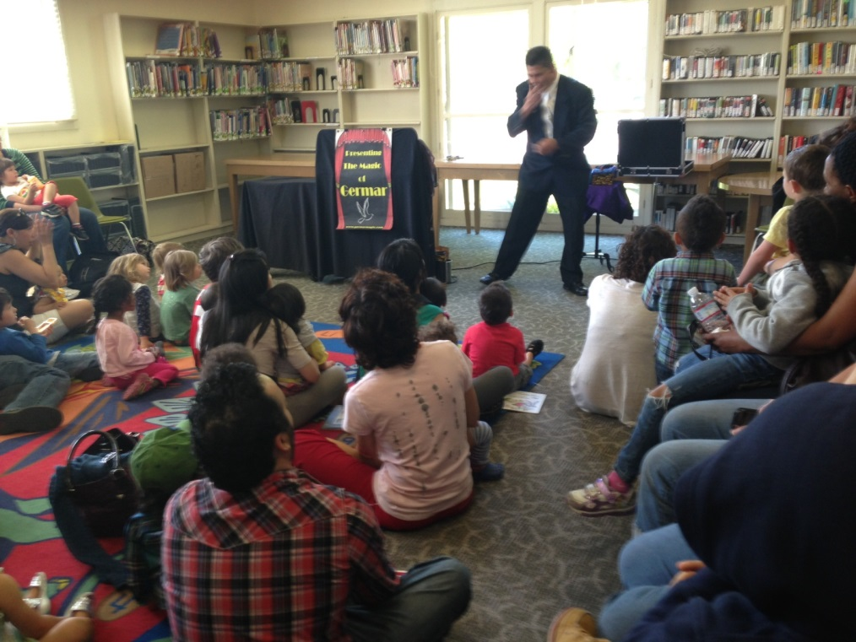

The group of program attendees was very diverse, both in age and racially. I initially counted around 40-45 children in attendance and around 25-30 adults, but this number did fluctuate throughout the program as some families left and some families wandered in. The majority of children in attendance were babies and toddlers, but there were some older children also present. Miriam, the children’s librarian, introduced the program as in conjunction with National Library Week, but there was no specific mention of El día de los niños/El día de los libros and the significance or purpose of this holiday. The performer for the event was Germar the Magician, a local entertainer based in Vallejo, California (Martinez, n.d.). Germar has won many awards and has had many big name clients; lists of both are available on his website (Martinez, n.d.).

The magic program was very fun and entertaining. Most of the children seemed to have a good time, though there were a few children who left in tears after some of the more startling illusions (i.e. a fake snake popping out of a hat). Many children and parents came and left throughout the event, but it remained consistently packed the entire program. The majority of Germar’s magic tricks involved the assistance of volunteer audience participants and this helped to make the children become really involved in what was going on in the different tricks. Interestingly, Germar also enlisted the help of parent audience members in a few different tricks as well, such as a trick with making a parent’s watch disappear and encasing another parent’s cellphone in a balloon. I also observed parents animatedly clapping and laughing at jokes. I believe this was a tacit used to help ease their children into enjoying the show by demonstrating how much they were enjoying the program themselves. Germar also used fun dance music throughout the program which gave it an air of excitement and fun. The use of elements of surprise in addition to sleights of hand and a lot of humor made the program very enjoyable. One of my critiques of the program overall would be that Germar was touted on the library’s event calendar as a bilingual magician but the entire program was only conducted in English. Germar did end his program by showing a few magic books that he got from the collection but I was surprised that more magic books were not on display by the librarian in the room we were in and the initiative to show the magic books was solely from the performer.

After the magic portion of the program concluded, Miriam invited everyone outside for refreshments and to receive their free book. A small table was set up close to the outside exit of the room where the program was held. The refreshments served were juice boxes, a big bowl of clementine oranges, and a bowl of crackers. On the same table Miriam had set up a big box filled with assorted paperback titles ranging with some picture book titles to some popular series for older children. Children and parents swarmed the table and many books were passed out within just a few minutes. Bookmarks, buttons, and stickers were also available for children that had a cute illustration of an El día de los niños/El día de los libros graphic on them. As the weather was so mild and pleasant that day, many families sat on the grassy area surrounding the Lakeview Branch library and enjoyed their snacks and new books.

*Interview*

I had originally set up an appointment to call Miriam after the event to ask her some questions about the program, but I actually had the opportunity to ask her some questions right after the program during the refreshment/book giveaway portion. In my interview with Miriam I asked her a list of seven questions that I had pre-planned prior to attending the event. In my first question, I was curious about what kind of publicity did she do for the event. I was surprised to learn that beyond the inclusion of the event on the library event calendar (available on-line and in print), not much extra publicity was done. Part of the reason for this was because of the timing of the event, which happened right after the family storytime program. Miriam said that normally attendance for the family storytime is usually under 50 people, but that for that day’s storytime twice as many people attended, closer to 100 people. Flyers for the event were also available at the branch itself, and the event was advertised to families attending the family storytime in the weeks prior to the El día de los niños/El día de los libros program. The target audience for the event was younger children, from the baby to toddler range, but all children and families were welcome and no one was turned away. My next questions were about how the library heard about the performer, how much was his fee, and how was the event paid for. I again was surprised to find out that Miriam actually did not hire the performer herself, rather the decision was made by the managers of the Children’s department located at the main library. Because of this she was not sure how much the event cost but she did note that Germar was actually was slated to perform seven other El día de los niños/El día de los libros shows at other branches of the OPL. Additionally, I learned that for the event Miriam was provided with $50 to purchase refreshments and around 50 books to be given out to attendees of this particular event. I also learned that Miriam considered this event to be “free programming” because it was offered to her by the Children’s managers and the payment of which did not come from her budget, which she estimated to be $800 dollars for the year and $800 for the summer. The funding for the event was from the Friends of the Oakland Public Library. Miriam also informed me that in addition to the books given to her to pass out at the event, she also supplemented those books with books she had gotten for free from the East Bay Children’s Book Project (East Bay Children’s Book Project, 2012). She estimated that she gave away around 80 books, which is 30 more than the 50 she was originally provided with. I had never heard of the organization before so I very much appreciated Miriam sharing her knowledge with me about it. I was also curious about the sound system that German used to play music during the event. I learned from Miriam that the performer brought all of his own sound equipment and was also responsible for setting it up.

*Conclusion*

Overall, I felt that the event was incredibly successfully and enjoyable for all attendees. The event was able to draw in at least twice as many families than the number that usually attends regularly held events at the branch. The magician was a good choice of performer because he was funny, highly entertaining, and often incorporated the help of children attendees into his act. Though the event wasn’t directly tied to the children’s collection at the Lakeview Branch, many books were given to families for free as part of the event. This high level of programming provided will keep families coming back to this library as a helpful and fun resource in their lives. I not only had the opportunity to observe this fun program, but I also had a great discussion with the branch’s children’s librarian as well. I honestly was a bit shocked to hear about how small her program budget for the year was, but was also very impressed at what she was able to accomplish with what little she had by being creative and resourceful. I was also glad to research and learn more about El día de los niños/El día de los libros, an event I had never heard about before. I hope to celebrate and incorporate this event into my own programming in my future career.

References

American Library Association. (2013). About día. *Día de los niños, Día de los libros.* Retrieved from http://dia.ala.org/content/about-d%C3%ADa

American Library Association. (2013a). Día de los niños, Día de los libros. *Día de los niños, Día de los libros.* Retrieved from http://dia.ala.org/

East Bay Children’s Book Project. (2012). About. *East Bay Children’s Book Project*. Retrieved from http://www.eastbaychildrensbookproject.org/about/

Martinez, G. (n.d.). Germar the magician. *The Magic of Germar.* Retrieved from http://www.germarmagic.com/index.html

Oakland Public Library. (n.d.). Lakeview branch. *Oakland Public Library*. Retrieved from http://www.oaklandlibrary.org/locations/lakeview-branch

Oakland Public Library. (2013, March 16). In *Wikipedia.* Retrieved from http://en.wikipedia.org/w/index.php?title=Oakland_Public_Library&oldid=544683173

OaklandWiki. (n.d.). Lakeview branch library. *OaklandWiki*. Retrieved from http://oaklandwiki.org/Lakeview_Branch_Library