Jennifer Archuleta

LIBR 202-04

Exercise #1

**Topic and Introduction**

The foundational and fundamental values of library and information professionals are not only to collect, preserve and organize various materials to meet the educational, recreational, and informational needs of the society in which they exist but to also connect the individuals that comprise those communities with those materials in a logical and skilled way. Traditionally, the roles of librarians have revolved around the library as a center of knowledge and as a physical space in which the materials- generally books, documents and different types of media- were housed. If people needed information they generally did not have many outlets in which to obtain it without the help of outside resources including the library and with the special knowledge and expertise of a librarian. Because of the boom in computer technologies over the past 20 years, the drop in the price of personal computers, the increase in opportunities to easily connect to the Internet both at home and through mobile devices, and with the increase in use of search engines such as Google, individuals today are more easily able to obtain information themselves through these means.

What has to be considered in this changing landscape of information access is what the role of the librarian in it is. Though information is readily available, individuals are usually not able to determine for themselves the quality of the sources available and the relevance to what their particular query or interest may be. The role of the 21st century librarian is unique and necessary to the landscape of information overload in order to provide the community with techniques and expertise on digital literacy. The digital divide is a reality in many communities where due to many factors individuals do not have the means to access digital information or the skills to process it to meet their needs. I believe that the library and librarians still have a role in the vast 21st century information landscape, and I am interested to learn more about their changing responsibilities from their traditional roles in relation to digital literacy.

Keywords I plan to use in my queries: digital literacy, 21st century, library, librarian, role, responsibilities, information overload, digital divide, millennium, information literacy, technological literacy

**Queries and Reflection**

*Google Scholar queries:*

1. “digital literacy” 2. Digital literacy and the 21st century librarian 3. “digital literacy” “21st century librarian” 4. “technological literacy” 5. "technological literacy" "millennium" "librarian" 6. "technological literacy" "21st century" "librarian" 7. "technological literacy" "21st century librarian" 8. “21st century librarian” 9. "21st century librarian" "literacy" 10. "information literacy" "digital divide" "librarian"

*Library Literature & Information Science Full Text queries:*

1. “digital literacy” in TX All Text Fields AND librarian in TX All Text Fields 2. Digital literacy 3. “21st century” AND “Librarian” 4. Technological literacy under SU Subject 5.DE “Information literacy” 6. “Information literacy” AND librarian 7. Librarian AND Technological literacy 8. Librarian AND Millennium 9. Librarian AND Millennium AND literacy 10. Digital divide AND Librarian

I started by looking for articles in GoogleScholar. I had to first configure GoogleScholar to search the SJSU library collections and set up RefWorks to be linked to search results. I approached GoogleScholar first because, like most people, I use Google multiple times a day for other IR services so the format was familiar and less intimidating for me to approach. Because of this comfort with the existing system in retrospect I realized that way I search is very much linked to how I search on Google. For example, I started with my first query, “digital literacy”, a broad area of my topic and immediately got 242,000 results, too many to work with. I then continued my searches to try to narrow my topic wording in order to also narrow my results.

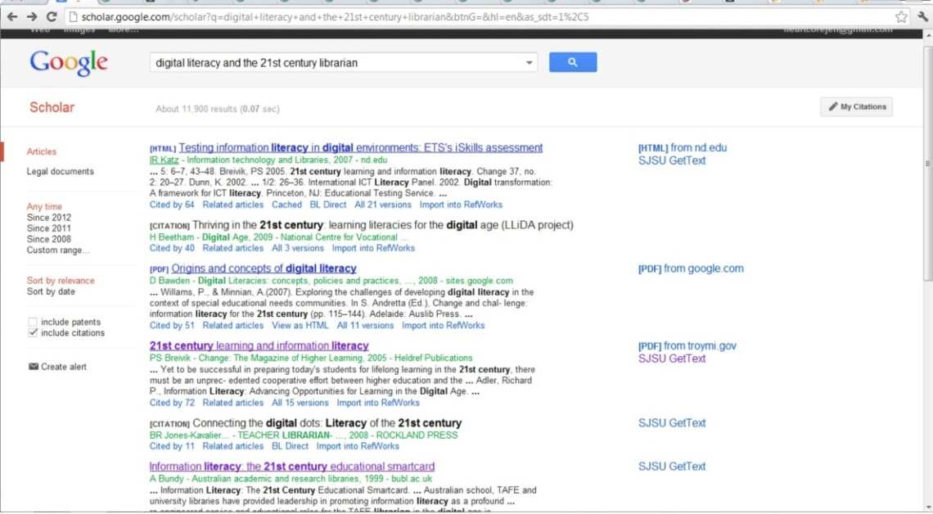

In this screen shot, I included more search terms related to my topic and my results decreased to 11,900, which was still too many but a big decrease from my first query. I realized after all my searching that this cycle of searching and feedback by changing search queries is what ultimately helped me to come up with better search terms and better combinations of search terms to narrow down the amount of articles that I had to go through. What I also was able to immediately see in my results pages was the “SJSU GetText” link on the right-hand margin of the article descriptions so I could easily browse through pages keeping an eye out for these items that I knew I would be able to get more easily and focused my efforts on those results. What I didn’t like compared to my searches in the Library Lit. database was that there was no way to limit the results to only items that had full text and items that were peer reviewed. If there was an option on GoogleScholar to limit items to those preferences I could have saved a lot of time going through articles that would have been too hard for me to get.

Accessing Library Lit. was a bit more of a lengthy process than accessing GoogleScholar as I had to first go to the SJSU Library website, find the related field in the article database page, find the Library Lit. database from a list and then had to sign in to my account in order to actually search the database. Searching in Library Lit. was similar in that I used a lot of the same keywords in my searches that I used in my GoogleScholar queries, but the layout of the searches themselves was quite different. You can see the physical differences in the sheer number of limits and refinements offered by Library Lit. in this screenshot of a query:

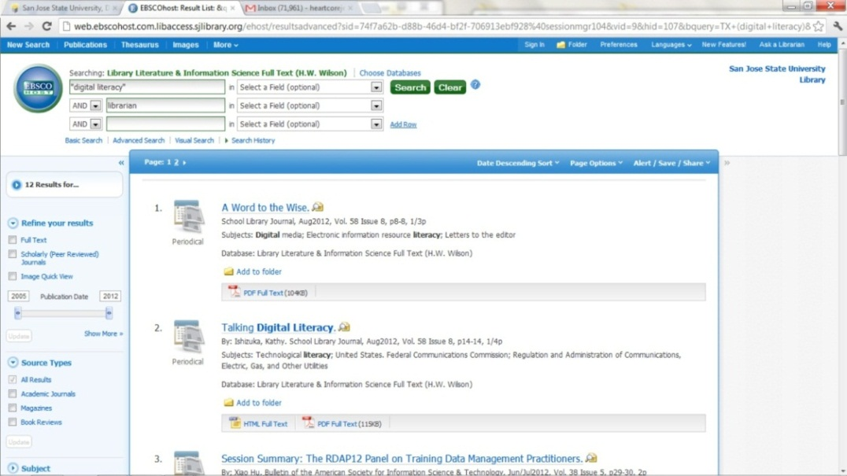

When searching for terms, Library Lit. provides three search boxes (with the option to add more) and pull down menus of operators to choose from for those boxes. Also, you can select what field you want to search for terms in, and though I usually stuck to not selecting a field to not narrow down my results I did try some searches under SU-Subject. Additionally, unlike GoogleScholar, Library Lit. does have an option to refine results to “Full Text” and “Scholarly (Peer Reviewed) Journals” in the left-hand margin, which I used in searches with many results to limit to items that would be more useful to me. Library Lit. also offers other refinements including different source types, different subjects and the ability to sort search results in different ways. A similarity between Library Lit. and GoogleScholar are icon links at the bottom of each record in the results page for “PDF Full Text”, “HTML Full Text”, or a “GetText” (for items not in the database) so like the “SJSU GetText” links in GoogleScholar I could easily look for these icons in articles that looked interesting to me. What is also helpful about searching through Library Lit. is the fact that is a library related database so the results are already in this field which my topic is in, whereas while searching in GoogleScholar many of my broader searches came up with results in fields also concerned with information literacy and the digital divide that were not relevant to my topic.

Accessing the digital articles that I was interested in was different in GoogleScholar than in Library Lit.. In GoogleScholar there was an extra step where after I clicked the “SJSU GetText” link it brought me to a page like this:

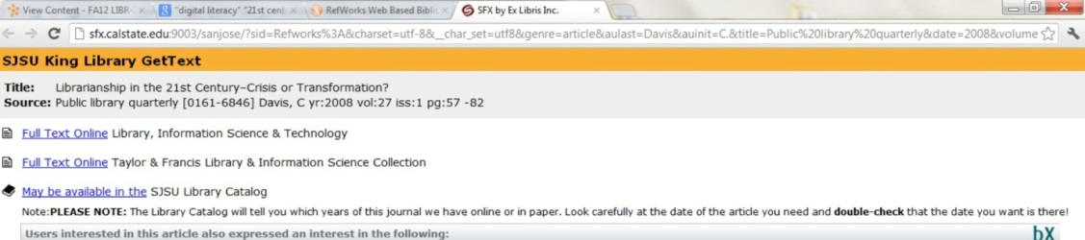

Where I then had to decide which database I wanted to access the work from. This process is different in Library Lit. as it is an actual database that already has many full text articles in it so when you are in the record for the digital item you are interested in you can easily access the “PDF Full Text” or “HTML Full Text” by clicking the links on the left-hand margin and it opens in the same page, no extra step is needed. Here is a screenshot of a full text PDF I was able to access through Library Lit. by clicking the link within the detailed item record:

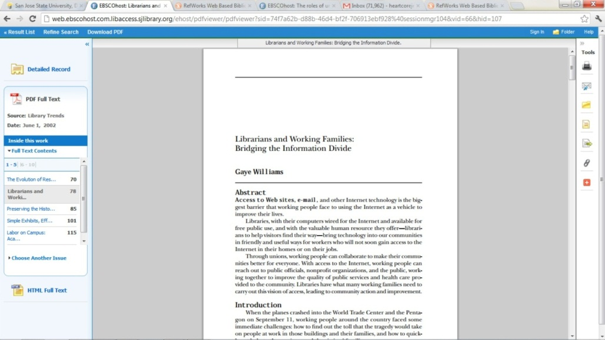

Exporting the references of the articles I was interested in from GoogleScholar and Library Lit. were quite similar except for a few differences. In GoogleScholar, as you can see in the first screen shot I included of a query, that after each summary of the record there is an “Import to RefWorks” which is visible. Once you click on this, you have to enter the SJSU RefWorks code: rwsjsu, in order to log in to RefWorks with your account information and then the reference is imported. In Library Lit., the option to export a reference to RefWorks is only available after you click a record result and are in the detailed information record. Though GoogleScholar and Library Lit. use the terms import and export, respectively, these are essentially the same process of sending the selected reference to RefWorks.

I liked being able to import all my references to RefWorks because it was a common service that I was able to use both in GoogleScholar and Library Lit. to organize and keep track of my articles. Once all of my references where imported to RefWorks from the different IR systems, I was able to add the full text PDF files that I saved on my computer to the RefWorks references themselves:

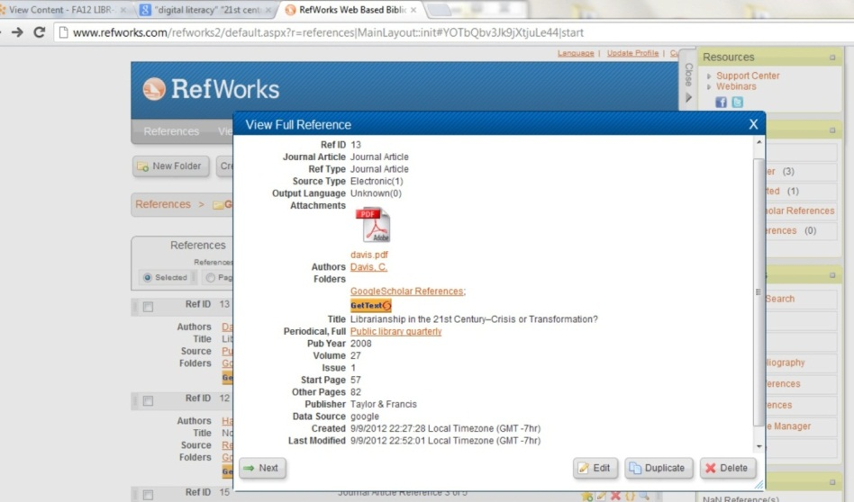

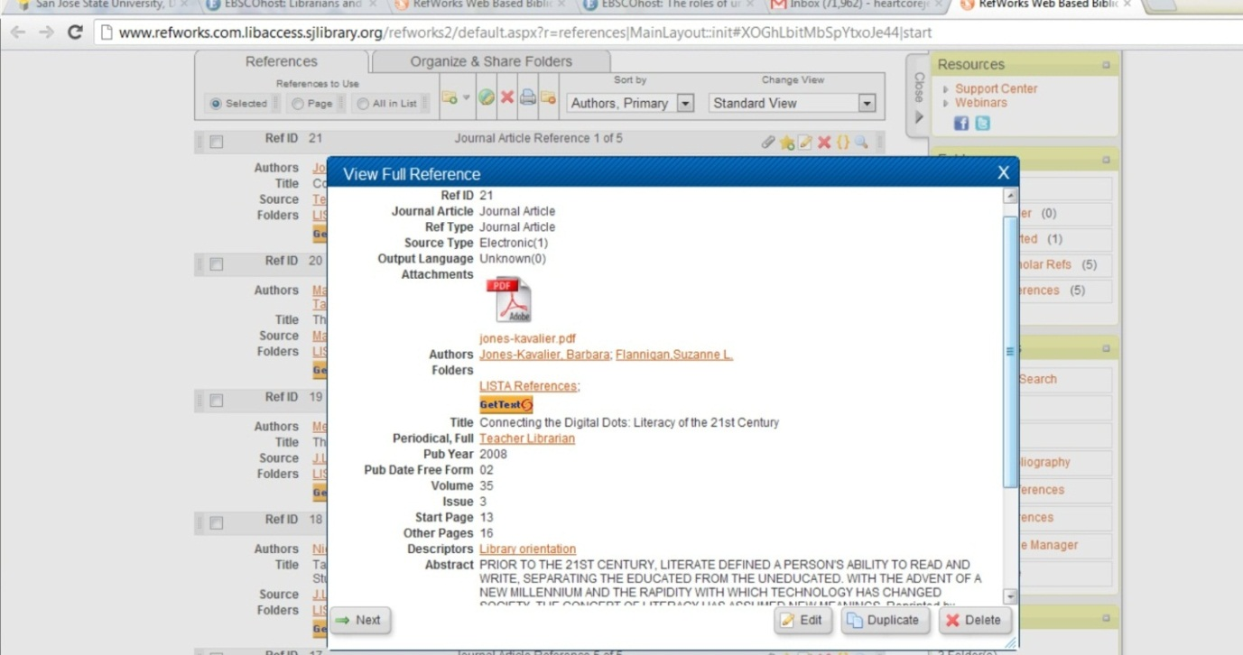

I also was able to create two different folders in RefWorks to house the different references from each IR System, one I titled “GoogleScholar References” and one “Library Lit. References”. This feature will be a useful for me in the future when I will be keeping track of multiple references for multiple courses and research projects. The only thing that was a bit inconvenient was to have to open each individual reference in order to edit it to be able to save in a specific folder, it would be nice if there was a feature to save a batch of references in a folder to save some time and sanity. Screenshots of the lists of references to 5 articles from GoogleScholar and Library Lit.:

