Jennifer Archuleta

Competency G

Evidence 3: Goodreads Folksonomy

Screenshot of my “used-for-storytime” bookshelf. A list of all of the other bookshelves that books within this category are tagged as appear on the left-hand panel:

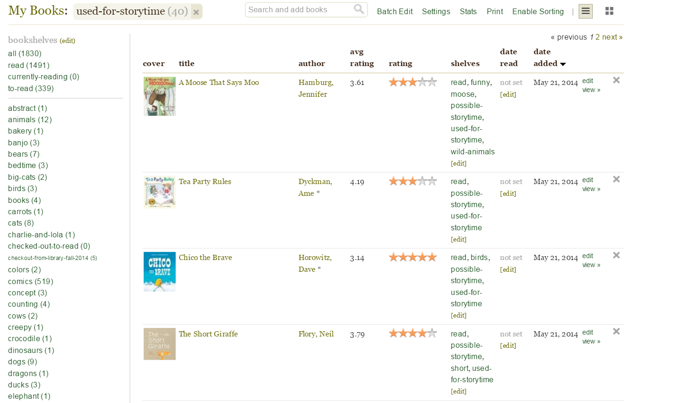

Screenshot of some of the tags I created for Goodreads to classify picture books used for my storytime programs:

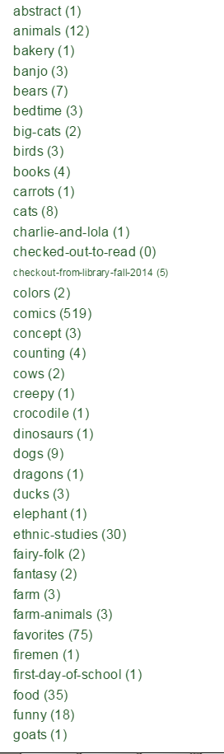

Closer look at an example of specific books I used for storytime, and the tags I created and assigned to them:

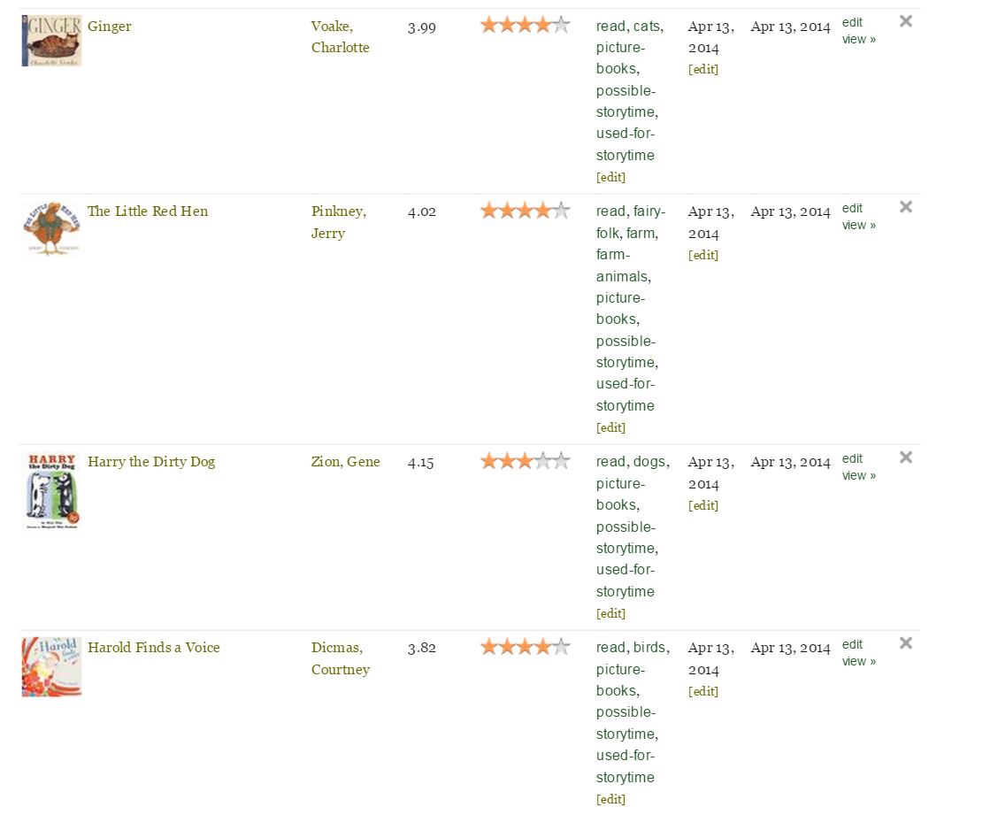

Screenshot of book recommendations from Goodreads, based on my “possible-storytime” shelf:

