Jennifer Archuleta
LIBR 202-04
Project #1

Part A: Building Awareness of Classification: Describe a Collection of Objects

Consider Theory

The introductory chapter, “To Classify is Human”, by Geoffrey C. Bowker and Susan Leigh Star from their book Sorting Things Out: Classification and Its Consequences gives an overview of what classifications and systems of classifications are, along with the often invisible but very real impact they have on our lives from the minute and personal to the formal and bureaucratic. They strive in this chapter and throughout their book to illustrate the ways in which classifications are not only prevalent everywhere but also to show how “their impact is indisputable, and…inescapable.” (Bowker & Star, 1999, p. 5) To understand better how these work we must understand how the authors define the terms classification, systems of classification, and standards. Bowker and Star (1999) define a classification as, “a spatial, temporal or spatio-temporal segmentation of the world” (p. 9). They define a classification system as, “a set of boxes (metaphorical or literal) into which things can be put in order to then do some kind of work- bureaucratic or knowledge production” (Bowker & Star, 1999, p. 9) They authors then go on to define the characteristics that an “abstract” and “ideal” (p. 9) classification should exhibit. These include the properties that a classification system- have “consistent, unique classificatory principles in operation” (p.9), classificatory principles meaning the way in which things are ordered and sorted such as temporal order (time) or functional order (usage), “the categories are mutually exclusive” (p.9), meaning categories are “clearly demarcated” (pg. 9) and that “any object addressed by the system will neatly and uniquely fit” (pg. 9), and lastly that the “system is complete” (p. 9) and that it “provides total coverage of the world it describes” (p. 9) so that even new objects to be considered into the classification have the possibility to “be absorbed into” (p. 9) the system instead of being ignored or discarded. Despite these properties of an ideal classification system, the authors acknowledge the idea that “no real-world working classification system that we have looked at meets these…requirements” illustrating the “conceptual, organizational and political dimensions” (Bowker & Star, 1999, p. 9) of systems in every day practice and use. Some of the “dimensions” (Bowker & Star, 1999, p. 11) they use to define standards include, “a ‘standard’ is any set of agreed-upon rules for the production of (textual or material) objects” (p. 11), they “span more than one community of practice” (p.11), they are used in “making things work together over distance and heterogeneous metrics”(p. 11), they are enforced by “legal bodies” (p.11), there is “no natural law that the best standard shall win” (p.11), and lastly “standards have significant inertia and can be very difficult and expensive to change” (p. 11). They authors point out that in a way these properties of standards “are in some sense idealized” (p. 11) much like the properties of systems of classification because they “embody goals of practice and production that are never perfectly realized” (p. 11)
In these definitions the authors (Bowker & Star, 1999) describe standards and classifications as “closely related, but not identical” (p. 10) and “two sides of the same coin” (p. 11). This is because systems of classification are used both in personal and informal ways (often not standardized) and in bureaucratic and formalized ways (often standardized). Bowker and Star (1999) state that systems of classifications “may or may not become standardized” (p. 11). Systems of classification that are not standardized are considered “ad hoc” (Bower & Star, 1999, p. 11) meaning they are “limited to an individual or a local community, and/or of limited duration” (p. 11). At the same time the authors (Bowker & Star, 1999) point out that “every successful standard imposes a classification system” (p. 11). With the definitions given by the authors of classification systems and standards it can be inferred that all standards employ classification systems, but not all classifications systems are standardized.

Description of Objects in Collection

This collection of objects is comprised of different types of nail polish. Nail polish is sometimes also referred to as nail lacquer or nail varnish. Nail polish is used for cosmetic purposes to both change and enhance the natural color of finger and toe nails through painting and decoration. Nail polish is used as a fashionable way to showcase ones personality and artistic expression through the personal choice and application of the myriad types available. Some types of nail polish even contain special additives such as vitamins and resins that can also physically affect the surface of the nail itself. Nail polishes come in a variety of brands, styles, prices and are widely available to individuals through many types of retailers including drugstores, big box stores, department stores, specialty beauty stores, boutiques, and online retailers. Usage of nail polish is traditionally enjoyed by women but is not exclusive to them especially in modern culture. Nail polish can be applied informally at home or by professionals in salons as part of a manicure or pedicure procedure.

Attributes of Nail Polish
Attribute #1 | Brand
Attribute #2 | Color Name
Attribute #3 | Color Description
Attribute #4 | Collection
Attribute #5 | Style #
Attribute #6 | Weight
Attribute #7 | County of Manufacture
Attribute #8 | Price
Attribute #9 | Container Dimensions
Attribute #10 | Barcode
Attribute #11 | Brush Style
Attribute #12 | D.T.F.(DBP,Toluene, Formaldehyde) Free?

Objects- Nail Polish | Attribute 1- Brand | Attribute 2- Color Name | Attribute 3-  Color Description | Attribute 4-Collection/  Year | Attribute 5-  Style # | Attribute 6-  Weight
1 | OPI | Thanks a Windmillion | opaque cream sage green | Holland/Summer  2012 | NL H62 | 0.5 Fl. Oz.
2 | Deborah Lippmann | Baby Love | sheer light pink | n/a | 20033 | .5 Fl. Oz.
3 | Butter London | Minger | opaque burnt orange | Fall/Winter 2009 | 0174 | .4 Fl. Oz.
4 | Sephora by OPI | Slushied | opaque turquoise | Glee 2011 | SE 292 | .5 Fl. Oz.
5 | Revlon | Pink Freeze | pearlescent hot pink | n/a | 250 | .5 Fl. Oz.
6 | Wet n’ Wild | Caribbean Frost | pearlescent emerald green | Wild Shine | 446C | .43 Fl. Oz.
7 | Essie | Navigate Her | cream lime green | Spring 2012 | 785 | .46 Fl. Oz.
8 | Essie | Coat Azure | medium blue with shimmer | Spring 2011 | 742 | .5 Fl. Oz.
9 | Essie | Chinchilly | opaque gray brown | Fall 2009 | 696 | .5 Fl. Oz.
10 | Zoya | Harlow | matte velvet purple | Matte Velvet | ZP505 | .5 Fl. Oz.
11 | Zoya | Trixie | metallic silver foil | Extreme | ZP389 | .5 Fl. Oz.
12 | American Apparel | Constellation | clear with silver glitter | Glitter | 53780 | .5 Fl. Oz.
13 | American Apparel | Downtown LA | opaque rich red | Original | 36506 | .5 Fl. Oz.
14 | American Apparel | Dynasty | opaque purple cream | Original | 36509 | .5 Fl. Oz.
15 | Sally Hansen | Ionic Indigo | metallic dark blue | Magnetic | 906 | .31 Fl. Oz.
16 | Beauty without Cruelty | Tangerine | cream coral orange | Attitude | 42 | .33 Fl. Oz.
17 | Sephora by OPI | Cartwheels on the Catwalk | cream mint green | Betsey Johnson | SE 325 | .5 Fl. Oz.
18 | Sally Hansen | Commander in Chic | opaque cream taupe | Complete Salon Manicure | 370 | .5 Fl. Oz.
19 | Julep | Kim | metallic gunmetal grey | Bombshell | 11559 | .27 Fl. Oz.
20 | Julep | Chloe | charcoal with magenta sparkle | Holiday 2011 | 1199193 | .27 Fl. Oz.
21 | Milani | Fresh Teal | opaque teal | Neon | 504 | .45 Fl. Oz.
22 | Sephora | Jungle Playground | pistachio green shimmer | n/a | L83 | .16 Fl. Oz.
23 | Sinful Colors | Rise and Shine | opaque teal shimmer | Professional | 940 | .5 Fl. Oz.
24 | Sally Hansen | Black Out | opaque black | Xtreme Wear | 370 | .4 Fl. Oz.
25 | POP beauty | Jade Metal | metallic green shimmer | Nail Glam | 50 | .5 Fl. Oz.

Objects- Nail Polish | Attribute 7- Country of Manufacture | Attribute 8- Price (USD) | Attribute 9-  Bottle Shape | Attribute 10-  Barcode | Attribute 11-  Brush Style | Attribute 12-  DTF Free?
1 | USA | $8.50 | round | 09427617 | Flat | yes
2 | USA | $16.00 | square | n/a | round | yes
3 | USA | $14 | rectangle | 85147002036 | round | yes
4 | USA | $8.00 | round | 619829075833 | Flat | yes
5 | USA | $5 | round | 091897041271-12 | round | yes
6 | China | $2 | rectangle | 077802350237 | round | yes
7 | USA | $8 | square | 884486086921 | round | yes
8 | USA | $8 | square | 08020574 | round | yes
9 | USA | $8 | square | 08069672 | round | yes
10 | USA | $8 | square | 132964 | round | yes
11 | USA | $8 | square | 10450095 | Round | yes
12 | USA | $6 | rectangle | n/a | round | yes
13 | USA | $6 | rectangle | n/a | round | yes
14 | USA | $6 | rectangle | n/a | round | yes
15 | USA | $9 | round | 07417938876 | Flat | yes
16 | U.K. | $16 | round | n/a | Flat | yes
17 | USA | $8 | round | n/a | Flat | yes
18 | USA | $6 | round | 074170352580 | Flat | yes
19 | USA | $14 | rectangle | 851833003511 | round | yes
20 | USA | $14 | rectangle | 851833003313 | round | yes
21 | USA | $5 | oval | 717489845045 | round | yes
22 | France | $4 | oval | 3378872056331 | Flat | F free
23 | USA | $2 | round | 00031735 | round | yes
24 | USA | $2.50 | round | 074170346541 | Flat | yes
25 | USA | $10 | rectangle | 995191500207 | round | yes

Part B: Description of a User Group

Consider Theory

The relationship between information retrieval systems, human cognition, information needs and the ways in which users create meaning in their personal lives must all be taken into account into the design of information retrieval systems. C.J. van Rijsbergen (1979) defines an information retrieval system in contrast to data retrieval in that it “does not inform (i.e. change the knowledge of) the user on the subject of his inquiry. It merely informs on the existence (or non-existence) and whereabouts of documents relating to his request” (p. 1). In this way, IR systems are used to find partial matches of queries and the inference used in IR is inductive meaning “relations are only specified with a degree of certainty or uncertainty and hence…confidence in the inference is variable” (Rijsbergen, 1979, p. 1). This degree of certainty or uncertainty can be thought of as “relevance” to a user and relevance is not static (Kuhlthau, 2004, p. 3), can vary over time (Kuhlthau, 2004, p. 4), and can even change as a user goes through the information searching process (Kuhlthau, 2004, p. 5). Carol Kuhlthau (2004) notes that the “bibliographic paradigm has been the traditional basis of the library and information profession” (p. 1) but has argued that a greater understanding of the user’s perspective is needed because it is a “critical component in information provision” (p. 2). She goes on to note that the narrow way in which user need for information has traditionally been studied does not take into account the “complex learning process in which individuals often engage as they search for information” (Kuhlthau, 2004, p.3). Gary Marchionini (1997) argues that humans are unique in their ability for metacognitive activity which he describes as the “ability to reflect on our own thoughts and actions in the past, monitor them as they proceed and plan which ones to take to meet our needs” (p. 4). Marchionini (1997) also discusses the concept of each user’s “personal information infrastructure” (p. 4) which he argues are guided by their “metacognitive activity directed at meeting situated information needs” (p. 4). Information seeking is a unique human “intellectual process” (Kuhlthau, 2004, p. 5) in which “information need” is defined as “an information search” that begins “with the user’s problem. The gap between the user’s knowledge about the problem or topic and what the user needs to know to solve the problem” (Kuhlthau, 2004, p. 5). As “human knowledge is dynamic” (Marchionini, 1997, p. 10) rather than “static” (Kuhlthau, 2004, p. 5) and due in part to metacognitive ability of humans, the user therefore “uniquely creates each search within the framework of his or her personal constructs related to the problem at hand and to his or her larger worldview” (Kuhlthau, 2004,7). Additionally, Marchionini (1997) argues that information retrieval “interfaces should also vary according to information-seeking task and personal characteristics” (p. 11) of each unique user. It is key to keep in mind that the information search is a “learning process in which the choices along the way are dependent on personal constructs rather than on one universal, predictable search for everyone” (Kuhlthau, 2004, p. 8)
Description of the User Group

The group of people or individuals who will benefit my database will be any person who is interested in finding out details about a certain kind of nail polish. These individuals will probably have an interest in the area of beauty and cosmetics in general that extends to the field of nail polish. I envision that people who fall within a continuum of expertise about nail polish to be able to benefit from the information provided by my database. Basic users who might be interested in the basic or simple facts about nail polish such as color or price will be able to find this information, but also more advanced users who may be interested in the uncommon knowledge included in the database will also benefit. Examples of basic users might be exclusive home nail polish users who purchase nail polish from drugstores and are more concerned with value than the brand appeal of high-end nail polish lines. An example of more versed, expert users may be members of the Makeupalley website forum (http://www.makeupalley.com/), where beauty enthusiasts rate and review beauty products. The purpose of the database is to offer information that is both basic (the brand, the color of the nail polish, the price) but also to offer information that is for the more advanced user (county of manufacture, D.T.F. free, collection.)

Some examples of possible questions by users:
Which nail polishes cost under $5?
What are some nail polishes that are green?
What brands of nail polishes have flat brushes for easier application?
Is Sephora by OPI Slushied a dark blue or light blue?
Is Deborah Lippmann Baby Love sheer or opaque?
What does American Apparel Downtown LA look like?
Which collection is Essie Chinchilly a part of?
Is American Apparel Downtown LA a part of the Neon collection?
Which nail polishes were released in Fall 2009?
Is ______nail polish DBP, Toluene, and Formaldehyde free?
Do Essie nail polishes come in round bottles?
How large is a ______ nail polish?
What country was _____nail polish made in?
What does ____nail polish look like in the bottle?
What does ____ nail polish look like on fingernails?

The attributes of nail polish needed to serve the user need:
Brand, price, name of nail polish, color description of nail polish, county of manufacture, D.T.F. free formula, collection, physical attributes (bottle shape, amount of nail polish), representation of nail polish (picture of nail polish bottles and picture of nail polish applied to fingers)

The attributes of nail polish needed to differentiate one entity from another:
Brand, name of nail polish, color description, county of manufacture, D.T.F. free formula, collection, physical attributes, representation of nail polish, barcode, price, style #

In going over these attributes and potential user need, I realize a more in-depth representation of what the nail polish actually looks like is needed for this database. Probably the most basic thing any user will want is to know what a nail polish looks like. Though I will be unable to take pictures of each color nail polish on actually finger or toenails, maybe the database could be set up for user contributions of this. I think that though barcode is a good way to distinguish each entity in this collection from another, it would be more for the benefit of the system itself rather that for the needs of the user who probably wouldn’t want to know about this information. I will instead adjust my included attributes to include a picture of each nail polish which will be for benefit of user need.

Amended Attributes (changed attribute highlighted):
Attributes of Nail Polish
Attribute #1 | Brand
Attribute #2 | Color Name
Attribute #3 | Color Description
Attribute #4 | Collection
Attribute #5 | Style #
Attribute #6 | Weight
Attribute #7 | County of Manufacture
Attribute #8 | Price
Attribute #9 | Bottle Shape
Attribute #10 | Image
Attribute #11 | Brush Style
Attribute #12 | D.T.F.(DBP,Toluene, Formaldehyde) Free?

Objects- Nail Polish | Attribute 1- Brand | Attribute 2- Color Name | Attribute 3-  Color Description | Attribute 4-Collection/  Year | Attribute 5-  Style # | Attribute 6-  Weight
1 | OPI | Thanks a Windmillion | opaque cream sage green | Holland/Summer  2012 | NL H62 | .5 Fl. Oz.
2 | Deborah Lippmann | Baby Love | sheer light pink | n/a | 20033 | .5 Fl. Oz.
3 | Butter London | Minger | opaque burnt orange | Fall/Winter 2009 | 0174 | .4 Fl. Oz.
4 | Sephora by OPI | Slushied | opaque turquoise | Glee 2011 | SE 292 | .5 Fl. Oz.
5 | Revlon | Pink Freeze | pearlescent hot pink | n/a | 250 | .5 Fl. Oz.
6 | Wet n’ Wild | Caribbean Frost | pearlescent emerald green | Wild Shine | 446C | .43 Fl. Oz.
7 | Essie | Navigate Her | cream lime green | Spring 2012 | 785 | .46 Fl. Oz.
8 | Essie | Coat Azure | medium blue with shimmer | Spring 2011 | 742 | .5 Fl. Oz.
9 | Essie | Chinchilly | opaque gray brown | Fall 2009 | 696 | .5 Fl. Oz.
10 | Zoya | Harlow | matte velvet purple | Matte Velvet | ZP505 | .5 Fl. Oz.
11 | Zoya | Trixie | metallic silver foil | Extreme | ZP389 | .5 Fl. Oz.
12 | American Apparel | Constellation | clear with silver glitter | Glitter | 53780 | .5 Fl. Oz.
13 | American Apparel | Downtown LA | opaque rich red | Original | 36506 | .5 Fl. Oz.
14 | American Apparel | Dynasty | opaque purple cream | Original | 36509 | .5 Fl. Oz.
15 | Sally Hansen | Ionic Indigo | metallic dark blue | Magnetic | 906 | .31 Fl. Oz.
16 | Beauty without Cruelty | Tangerine | cream coral orange | Attitude | 42 | .33 Fl. Oz.
17 | Sephora by OPI | Cartwheels on the Catwalk | cream mint green | Betsey Johnson | SE 325 | .5 Fl. Oz.
18 | Sally Hansen | Commander in Chic | opaque cream taupe | Complete Salon Manicure | 370 | .5 Fl. Oz.
19 | Julep | Kim | metallic gunmetal grey | Bombshell | 11559 | .27 Fl. Oz.
20 | Julep | Chloe | charcoal with magenta sparkle | Holiday 2011 | 1199193 | .27 Fl. Oz.
21 | Milani | Fresh Teal | opaque teal | Neon | 504 | .45 Fl. Oz.
22 | Sephora | Jungle Playground | pistachio green shimmer | n/a | L83 | .16 Fl. Oz.
23 | Sinful Colors | Rise and Shine | opaque teal shimmer | Professional | 940 | .5 Fl. Oz.
24 | Sally Hansen | Black Out | opaque black | Xtreme Wear | 370 | .4 Fl. Oz.
25 | POP beauty | Jade Metal | metallic green shimmer | Nail Glam | 50 | .5 Fl. Oz.

Objects- Nail Polish | Attribute 7- Country of Manufacture | Attribute 8- Price (USD) | Attribute 9-  Bottle Shape | Attribute 10-Image | Attribute 11-  Brush Style | Attribute 12-  DTF Free?
1 | USA | $8.50 | round | 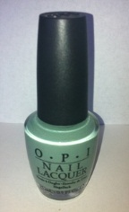 | flat | yes
2 | USA | $16.00 | square | 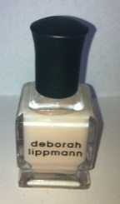 | round | yes
3 | USA | $14 | rectangle | 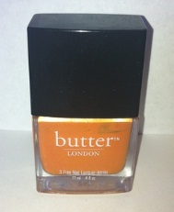 | round | yes
4 | USA | $8.00 | round | 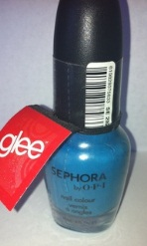 | flat | yes
5 | USA | $5 | round | 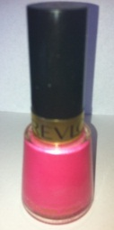 | round | yes
6 | China | $2 | rectangle | 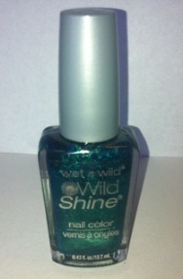 | round | yes
7 | USA | $8 | square | 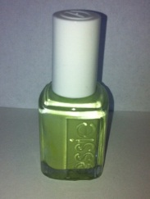 | round | yes
8 | USA | $8 | square | 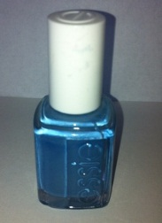 | round | yes
9 | USA | $8 | square | 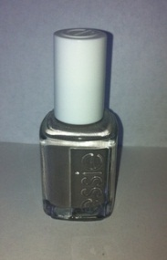 | round | yes
10 | USA | $8 | square | 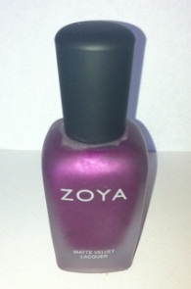 | round | yes
11 | USA | $8 | square | 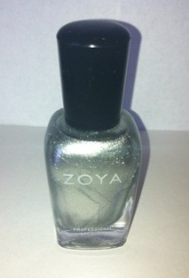 | Round | yes
12 | USA | $6 | rectangle | 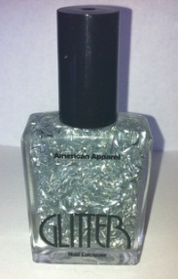 | round | yes
13 | USA | $6 | rectangle | 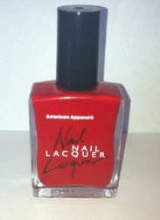 | round | yes
14 | USA | $6 | rectangle | 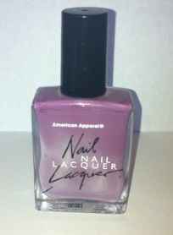 | round | yes
15 | USA | $9 | round | 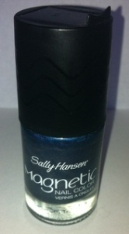 | flat | yes
16 | U.K. | $16 | round | 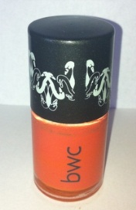 | flat | yes
17 | USA | $8 | round | 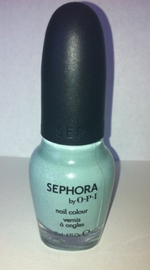 | flat | yes
18 | USA | $6 | round | 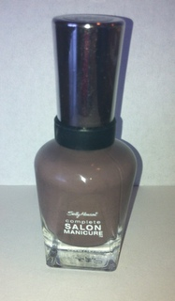 | flat | yes
19 | USA | $14 | rectangle | 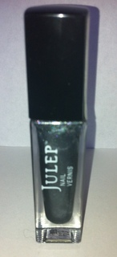 | round | yes
20 | USA | $14 | rectangle | 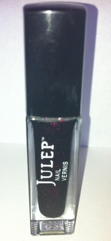 | round | yes
21 | USA | $5 | oval | 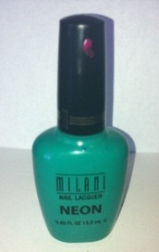 | round | yes
22 | France | $4 | oval | 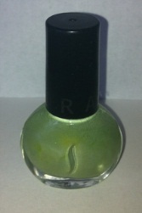 | flat | F free
23 | USA | $2 | round | 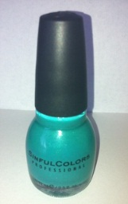 | round | yes
24 | USA | $2.50 | round | 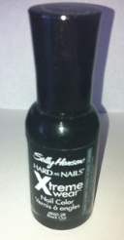 | flat | yes
25 | USA | $10 | rectangle | 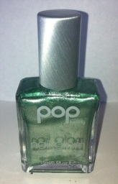 | round | yes

References

Bowker, G. C. & Star, S. L. (1999). Sorting things out. Cambridge, Mass.: MIT Press.
Kuhlthau, C. C. (2004). Seeking meaning: A process approach to library and information services (2nd ed.). Westport, Conn.: Libraries Unlimited
Marchionini, G. (1997). Information seeking in electronic environments. Cambridge; New York: Cambridge University Press.
Rijsbergen, C. J. v. (1975). Information retrieval. London; Boston: Butterworths.

