Jennifer Archuleta

Berkeley Public Library: Book and Material Displays

Competency D, Evidence 4

Display 1: Read Local-

Photograph of display. Note printout with QR on left of bottom shelf:

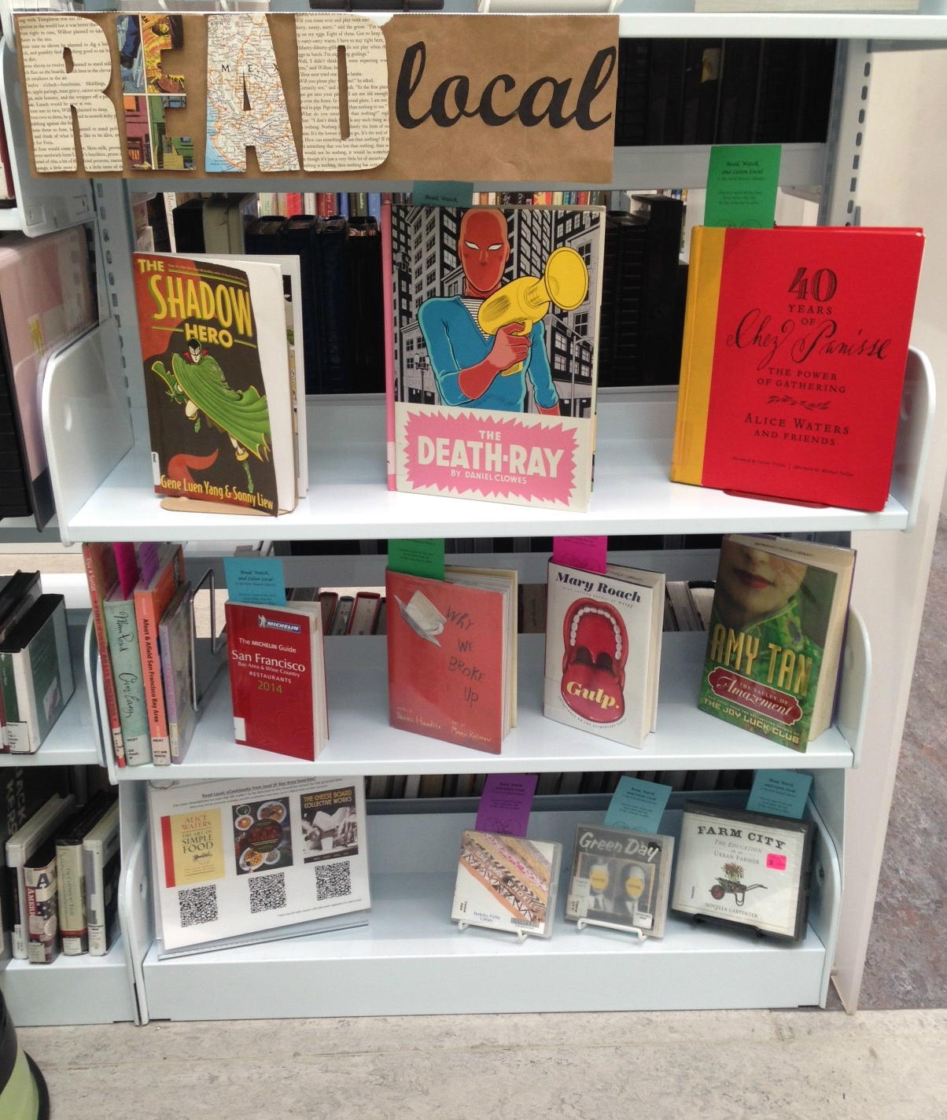

Read Local bookmark:

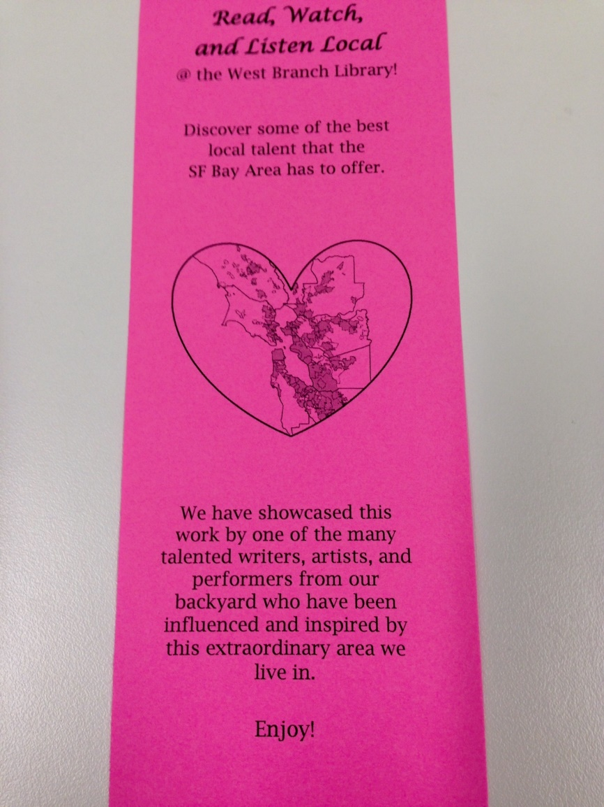

Display 2: Blind Date with a Book-

Photograph of display:

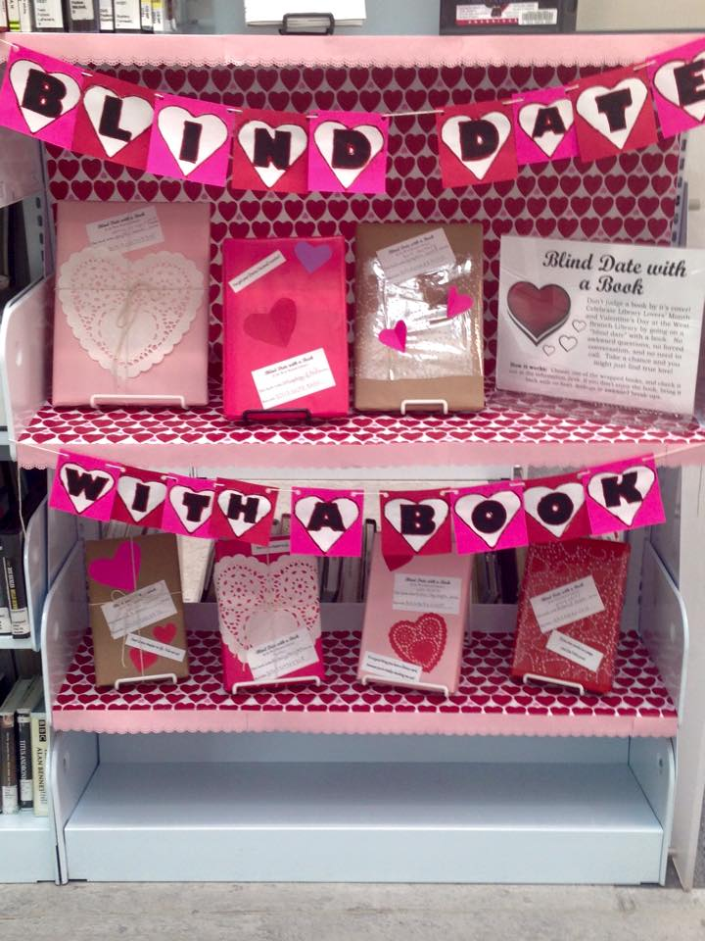

Display 3: Women’s History Month-

Photograph of display:

