Jennifer Archuleta

LIBR 202-04

Project #3

**Evaluation of an Information Retrieval System**

***Part I: Analyze concepts from the readings***

Author, academic in the fields of cognitive science, design, and usability engineering, and co-founder of the Nielsen Norman Group, Donald A. Norman, discusses and introduces concepts integral to the design and psychopathy of everyday things in his perennial book, *The Design of Everyday Things.* The book published in 1988, begins with the first chapter, “The Psychopathy of Everyday Things”, which serves as an introduction to many concepts that Norman believes are vital to the good design of objects and devices. Admittedly, I am not a scholar in any of the fields from which Norman originates, but I find that his description of the everyday dilemmas that he finds himself in due to problems of poor design, and how these are linked to the concepts of the psychopathy of everyday things present interesting and useful ideas for many other fields, including information retrieval studies and information seeking. In this section I will define some of the key concepts that Norman introduces as integral to the psychopathy of everyday things and good design, in addition to describing the kinds of information these concepts help convey and how these theoretical concepts are helpful for individuals who study information seeking. These key concepts are: affordances, constraints, mapping, natural mapping, conceptual and mental models, and the paradox of technology.

Norman (1988) states that people are able to cope with the massive amount of everyday objects that they encounter in two different ways; the first is by the way the human mind works, “the psychology of human thought and cognition” (p. 12), and the second is by the “information available from the appearance of the objects” (p. 12), their “visible structure” (p. 12) which come from “affordances, constraints, and mappings” (p. 12). Norman (1988) defines the term affordance as, “the perceived and actual properties of the thing, primarily those fundamental properties that determine just how the thing, could possibly be used” (p. 9). In a sense the concept of affordance is synonymous with the phrase, “is for” (Norman, 1988, p. 9). The example Norman (1988) presents is, a “chair affords…support and, therefore, affords sitting” (p. 9). The concept of affordances is important because they “provide strong clues to the operations of things” (Norman, 1988, pg. 9). Norman (1988) argues that when “affordances are taken advantage of, the user knows what to do just by looking: no picture, label, or instruction is required” (p. 9) and that “when simple things need pictures, labels, or instructions, the design has failed” (p.9). This concept is useful to those who study information seeking because affordances must be taken advantage of, otherwise poor design will ensue and in turn information seeking will be more difficult for the user.

Another key concept that Norman (1988) introduces as part of the “visible structure” (p.12) of objects is that of constraints. In order to find the definition of this term, we must look to a later work (published in 1999) by Norman, “Affordance, Conventions, and Design”, in which he further clarifies many of the concepts originally introduced in “The Psychology of Everyday Things”, partially as a response to designers who were incorrectly using some of these terms but also to elaborate upon what he means by them. When Norman (1999) discusses the term constraints, he clarifies that he is specifically referring to “behavioral constraints” (p. 40), which he further breaks down into three distinctions: “physical, logical, and cultural” (p.40). Physical constraints “are closely related to real affordances” (Norman, 1999, p. 40), they “make some actions impossible: there is no way to ignore them” (p.41). Logical constraints “use reasoning to determine the alternatives” (Norman, 1999, p. 40), are “valuable in guiding behavior” (p. 40), and “go hand in hand with a good conceptual model” (p. 40). Lastly, cultural constraints are “conventions shared by a cultural group” (Norman, 1999, p. 40). Norman (1999) argues that logical and cultural constraints are “weaker in a sense that they can be violated or ignored, but they act as valuable aids to navigating the unknowns and complexities of everyday life” (p. 41). The concept of constraints is an important idea for those who study information seeking because understanding the power of constraints will help guide users to find the information they are seeking in the best possible way.

The last concept related to the “visible structure” (Norman, 1988, p. 12) of objects is the concept of mapping. Norman (1998) defines mapping as “the relationship between two things, in this case between the controls and the movements and the results in the world” (p. 23). This concept is closely tied to the concept Norman (1988) describes as natural mapping, which is “taking advantage of physical analogies and cultural standards” (p. 23) and can lead “to immediate understanding” (p.23). There are different types of natural mappings, some are cultural or biological in nature, such as “the universal understanding that a rising level represents more, a diminishing level, less” (Norman, 1988, p. 23), and other natural mappings “follow from the principles of perception and allow for the natural group or patterning of controls and feedback” (p.23). There are many reasons why these concepts are important to those studying information seeking. The first is that “mapping problems are…one of the fundamental causes of difficulties” (Norman, 1988, p. 23). A device or object is “easy to use when there is visibility to the set of possible actions, where the controls and displays exploit natural mappings” (Norman, 1988, p.25). In order for a device to have good design and allow ease of use, “there must be a close, natural relationship between the control and its function” (Norman, 1988, p. 27). When mapping is confusing or not closely correlated to control and function, problems and confusion will arise for the information seeking user.

Two other crucial concepts are discussed by Norman; those of conceptual models and mental models. Conceptual models allow us to “mentally simulate operations” (Norman, 1988, p.12) of objects or devices. Norman (1988) argues that providing a good conceptual model is a fundamental principle of designing for people (p. 13). Conceptual models are important because a good conceptual model “allows us to predict the effects of our actions” (Norman, 1988, p. 13). Norman (1988) further argues that “for everyday things, conceptual models need not be very complex” (p. 14), we simply need to understand “the relationship between the controls and the outcomes” (p.14). When a conceptual model “presented to us is inadequate or wrong…we can have difficulties” (Norman, 1988, p.14). Conceptual models are “part of an important concept in design: mental models” (Norman, 1988, p. 17). Norman (1988) defines mental models as “the models people have of themselves, others, the environment, and the things with which they interact. People form mental models through experience, training, and instruction” (p. 17). A mental model of an object or device is “formed largely by interpreting its perceived actions and its visible structure” (Norman, 1988, p. 17). These closely related concepts are important for individuals who study information seeking because they delve into the deeper workings of the human brain; how it learns and creates mental models and uses conceptual models in order to navigate the world. When conceptual models are “false” (Norman, 1988, p. 16) they can present difficulties for the information seeking user. When mental models of users are not taken into account in the design of information retrieval systems, users will have a hard time learning and understanding them.

The last concept that Norman (1988) discusses in “The Psychopathy of Everyday Things” is that of the paradox of technology. Norman (1988) argues that “technology offers the potential to make life easier and more enjoyable; each new technology provides increased benefits. At the same time, added complexities arise to increase our difficulty and frustration” (p. 29). Technology today has the ability to do a great many things that were not possible or poorly executed in the past. The sheer amount of technological advances in recent years has created the ability for us to do more than ever with our devices. The paradox of technology refers to the hindrance of this large number of advances, that when not designed properly, can actually have a negative effect for users instead of providing users with more options and capabilities. As Norman (1988) states, “the same technology that simplifies life by providing more functions in each device also complicates life by making the device harder to learn, harder to use” (p. 31). This is a very important concept for individuals who study information seeking to be aware of because we live in a technologically advanced time where the devices we use and encounter are increasing complex in their attempt to offer simplification of our lives. There is a learning curve of understanding needed for many of these devices, that when executed poorly can make information seeking harder for users, not easier.

**References**

Norman, D. A. (1988). *The psychology of everyday things*. New York: Doubleday.

Norman, D. A. (1999). Affordance, conventions, and design.*Interactions, 6*(3), 38-43.

***Part II: Apply these concepts to a brief evaluation***

In this section I will use the concepts discussed and defined in Part I to evaluate the interface of the information retrieval, library-based service, RefWorks. In order to do this I will evaluate some of the features of the RefWorks interface associated with importing an attachment within a specific reference. I will evaluate what works and what doesn’t about these different features in terms of the concepts defined and discussed by Norman.

**RefWorks functionality**: Importing an attachment within a specific reference. RefWorks allows users to upload and save their own files within a specific reference.

**Feature 1**: Getting to “Edit Reference” Window.

The ability to upload an attachment to RefWorks is a learned action. Prior to taking this course, I thought that RefWorks was a service that could only organize references; I did not know that uploading files to be associated with these references was possible. Prior to this course my mental models were based on my past experiences with RefWorks (very little, to no experience), and after Project #1 my mental models for on this functionality were based on instruction (our class was given specific instructions on how exactly to upload an attachment to a reference) and experience (we had to perform the action ourselves and post successful screenshots as part of the assignment). Users who are not aware of this functionality of Refworks will not have any past mental models on which it draw from, and probably will remain unaware of this function. There are no conceptual models that exist to guide the user to this function, and it is not clearly stated or visible. Knowledge based on mental models of getting to the “Edit Reference” window must be based on prior knowledge, instruction or experience with this specific interface. We will proceed, with the understanding that my learned mental models are needed to get to this stage.

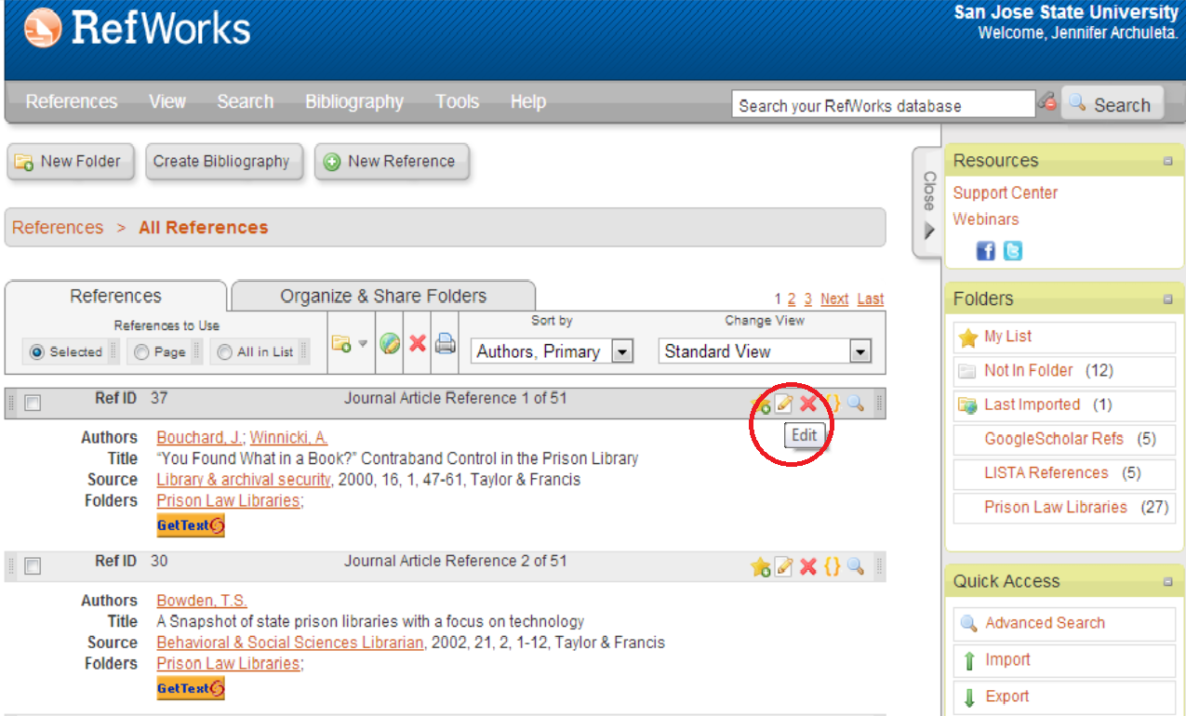

In this first screenshot, it is evident that there are a plethora of buttons, functions and things possible in RefWorks. Clearly, the interface suffers from the paradox of technology; in the attempt to make references easily accessible while offering a multitude of functions, confusion ensues and a high learning curve is needed to understand how to get even the most basic things done. Additionally, the paradox of technology is also evident in this interface because there are multiple ways of doing the same thing, thereby complicating one action into many possible actions. There are two different ways of getting to the “Edit Reference” screen. The first way, as illustrated above, is made easier with the icons placed at a header above each reference. The icons afford clicking, and offer a clear mapping in terms of the conventions of how computers icons and cursors interact. In this case, when the cursor is held over the different icons, a little text box pops up that specifics the functionality of the icon when clicked. This provides for the user a clear conceptual model about what they can expect to happen when the icon is selected, without actually having to perform the task. In this case, when the cursor moves over the icon with the image of the paper/pencil, the text box with the word “Edit” appears. The second way of getting to the “Edit Reference” window is by clicking on the icon shaped like a magnifying glass, which opens the “View Full Reference” window:

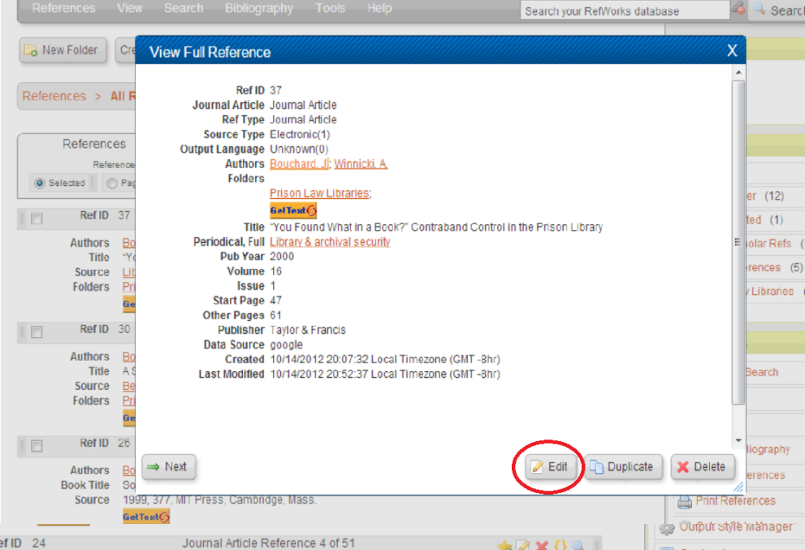

In this pop-up screen, there is an edit button available at the bottom, though new users without previous mental models, are not given a clear conceptual model that this edit functionality exists within the “View Full Reference”, users who are aware of this probably will be aware of it due to trial and error and self-exploration as mapping is not utilized well here.

**Feature 2**: Navigating the “Edit Reference” Window

Once in the “Edit Reference” window, users must make of prior mental models in addition to the cultural constraints (conventions) about computer usage in order to navigate this window.

This is a screenshot of what the “Edit Reference” window looks like once successfully opened:

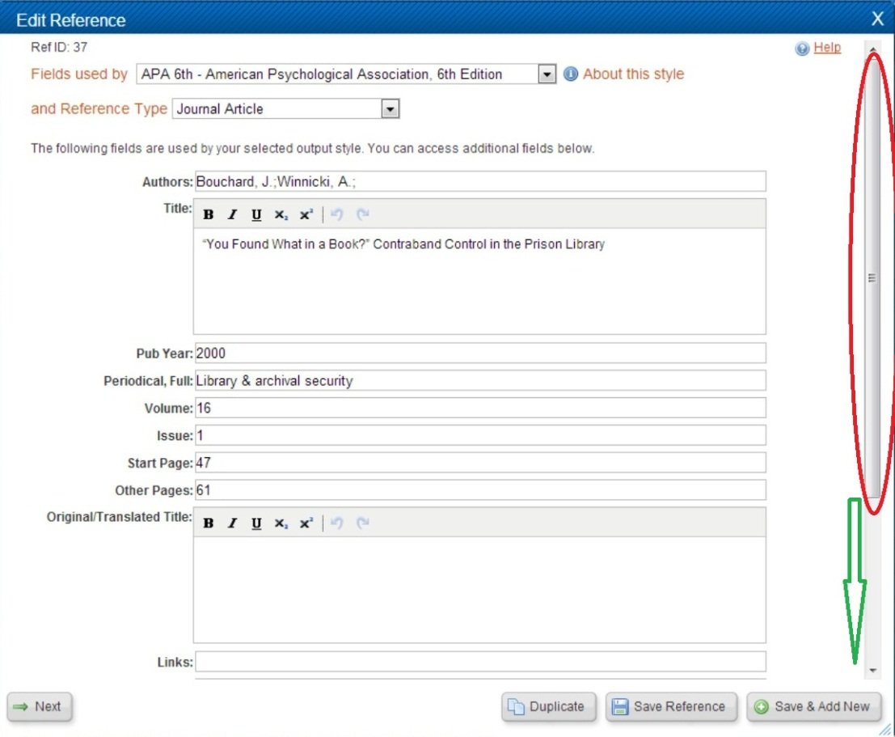

When a user first views this window there are immediately many functions available to the user. Any of the fields can be edited as stated by the interface. At first glance there are no options to upload files to this reference. Users must base their navigation of this window on their previous interactions with windows from other (using mental models) computer programs. As I have highlighted in the screenshot, users who have prior understanding, instruction, and experience with computers will immediately recognize the function of the scroll bar on the right hand side. Computer cultural constraints (conventions) dictate that scroll bars will always appear on the right hand side and have a similar appearance. The use of the scroll bar in this window highlight the proper uses of the concepts of natural mapping and conceptual models. The scroll bar is currently in a spot that provides a conceptual model to the users about where on the page the user is located. The use of space filled with the scroll bar and the empty space below, gives a clear conceptual model to users that there is roughly that much space still below the current position. Natural mapping is also in play here. It is common convention in the United States that people read from up to down, and the scroll bar utilizes this in the form of natural mapping. In order to move down on the scroll bar, you click the downward pointing arrow, and the position on the page moves accordingly. When you want to scroll up, you click on the upward pointing arrow, and your position on the page moves up. Using these indicators provides clues to the users that there is more information that is not immediately visible, directly under the current view of the page, and that one must scroll down for this information. Once the user successfully uses the conceptual concepts and the natural mapping of the scroll bar they will be able to see the space for attachment uploads:

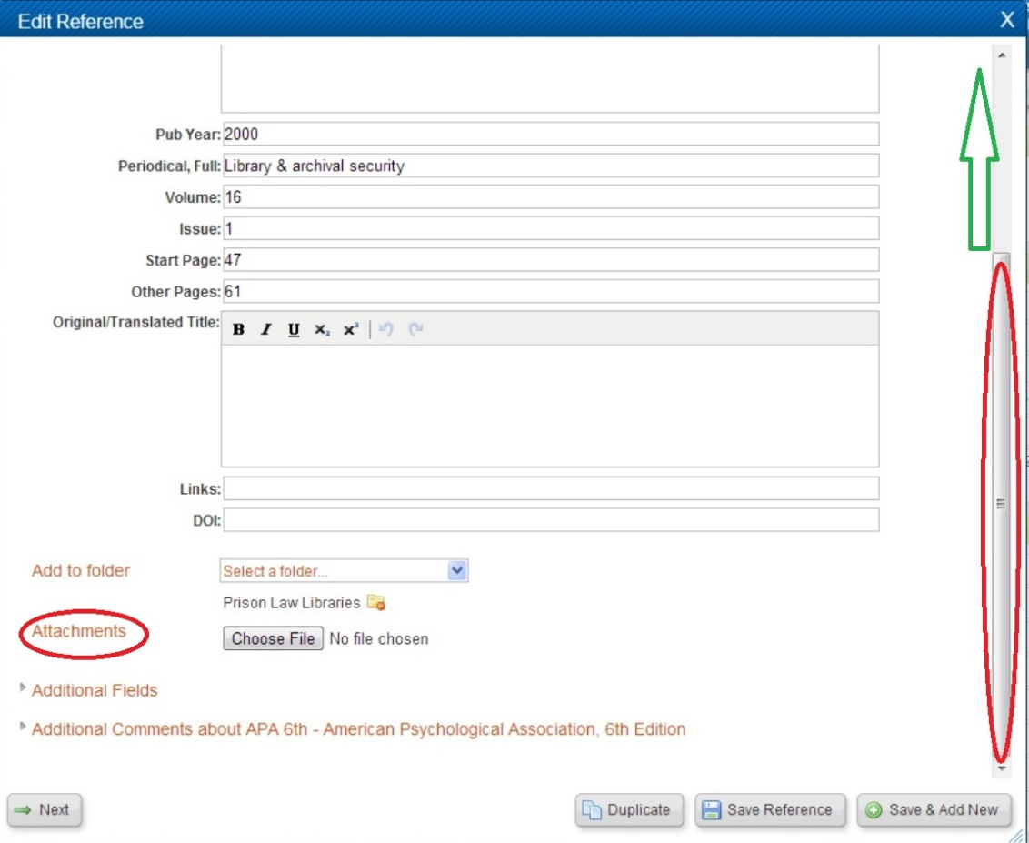

**Feature 3**: Uploading a file attachment to the reference.

Once the user has successfully navigated to the part of the “Edit Reference” window that specifies attachments, they can upload a file to the reference. Again, past mental models about prior experience with the functionality of computers is needed on the part of the user. When viewing the attachment line of the “Edit Reference” window, there is a button there that affords clicking with the cursor of the computer. Again, good conceptual models are made use of here; when the cursor is placed over the “Choose File” button, a pop-up text box indicates to the user that “no file chosen”, letting them know that no file has been successfully uploaded. The words “no file chosen” also appears to the right hand side of the “Choose File” button, when no file has been uploaded. Use of both the pop up and the text seems redundant, but it does give the user a clear message that no files are associated with this reference.



Once a file has been chosen from the users computer, the RefWorks interface makes good use of constraints and conceptual models to provide the user with feedback about the uploading of their file. After a file has been chosen, the interface immediately uploads the file to the reference. In order to indicate to the user that this process is being done, the “Edit Reference” window is grayed out, constraining the user with the ability to no longer have access to that screen, indicating that another screen has appeared. The conceptual model of a blue box with the words “Processing…Loading- Please wait” in the bottom right hand corner gives users immediate feedback that their action of selecting a file from their computer has resulted in this direct relationship/response. When the “Processing” window disappears and functionality to the “Edit Reference Window” is restored, users are again given a conceptual model that something has been accomplished as a direct result of their actions.

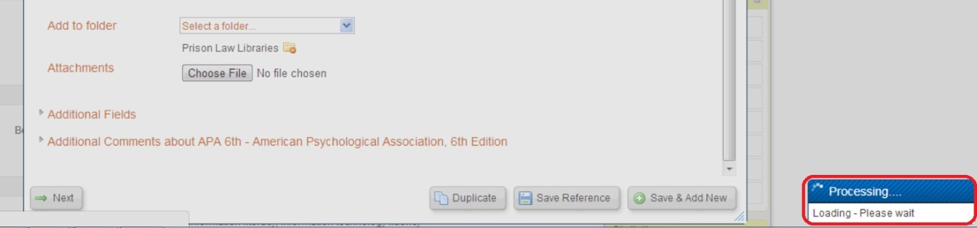

This is indicated to the user by use of an icon with the uploaded file name, now listed in the attachment area:

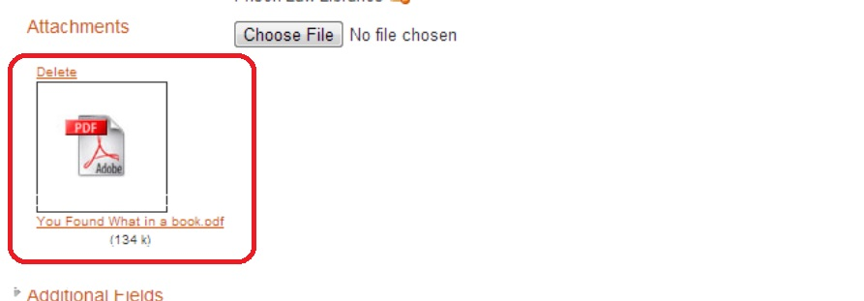

With proper use of these visual clues, feedback, and good conceptual models, users are able to determine that they have successfully accomplished their task. The process of uploading a file to RefWorks may actually be much more complicated than with what users are presented, but users do not need to understand this process. They simply need to be provided with a good conceptual model in order to understand the relationship between them clicking the “Choose File” button and the file being uploaded by the interface.

**Feature 4:** Viewing and downloading a file from a Reference.

Once a user has successfully uploaded an attachment file to a reference, these files can be viewed as part of the reference and also downloaded from the RefWorks interface. When navigating back to the home screen we originally viewed users who have uploaded a file on a reference are given a good natural mapping and conceptual model of this fact by appearance of a new icon:

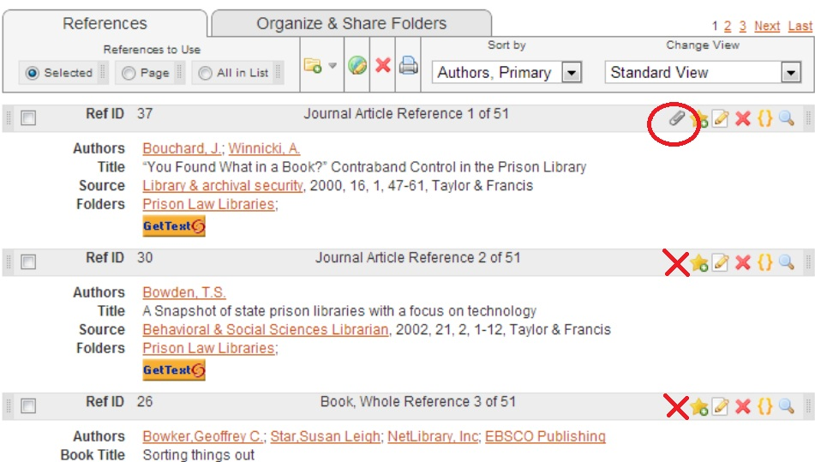

As can be seen in this screenshot, the reference for which a file has been uploaded now displays a paperclip shaped icon. Paperclips are a convention on computers that usually signal an attachment, such as in an e-mail program. As can be also been seen in the screenshot, the other references that do not have attachments associated with them do not display the paperclip icon, indicating to the user that there are no attachments for those references. As with the first example of the paradox of technology in Feature 1, the paradox again is again evident in this feature of the interface as there are multiple ways to perform the same function, in this case viewing the attachment in the reference. The most obvious way for the user to do this is to use the “view” icon, to pull up the “View Full Reference” screen:

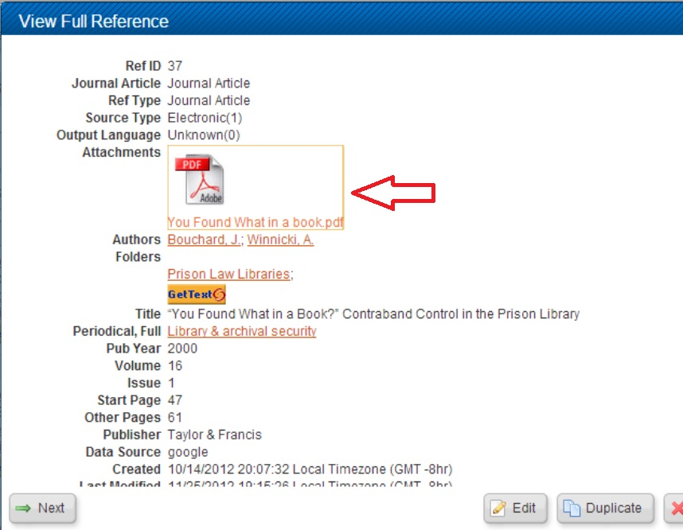

In this window the user can see what attachments are associated with the reference. Another way that the user can view what files are associated with the reference is to use the “Edit Reference” option where the user can see the file and also delete it is necessary:

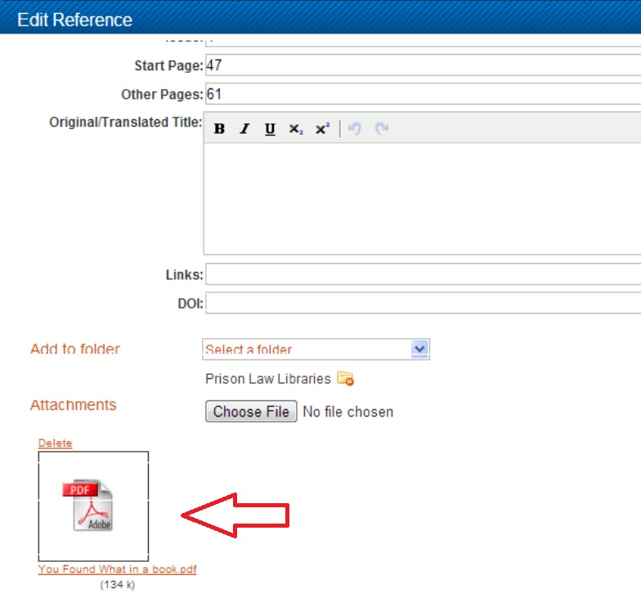

This paradox of technology is again evident when the user wants to utilize the download file feature of the interface. There are two different ways that the user can accomplish this task, creating multiple mappings and multiple conceptual models that can be confusing for users to keep track of and remember how to use again in the future. In order to download the file to the user’s computer, the user can easily do this by clicking on the paperclip icon, shown in the first screenshot of this feature’s section. Upon clicking, the interface provides immediate feedback by beginning to download the item to the user’s computer. A nice conceptual model provided by this process is given when the cursor is placed over the paperclip icon. RefWorks allows multiple uploads for each reference, so when a user wants to download just 1 file (if multiple are uploaded), the interface provides a popup window with the names of each file:



The conceptual model of what will happen is futher made clear by the interface. When the item to be downloaded is selected the background of the file name will turn a slightly darker color,

clearly indicating to the user that the item has been selected to be downloaded:



This gives the user a clear conceptual model of what will happen, without actually having to go through with the process. A second way that the files can be downloaded is again through the “View Full Reference” window. When the user initially looks at this page they will see the files associated with the reference:

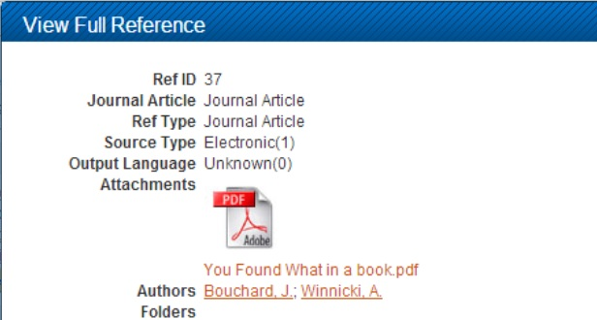

There is no clear indication to the user that clicking on the item will lead to downloading at first glance. The use of the Adobe PDF icon does afford clicking, but not every such icon will lead to a download. The interface does provide a slight conceptual model for users to indicate when the item is selected. When the cursor moves over any part of the file icon the font color changes to a slightly brighter/lighter orange, indicating to the user that that particular file has been chosen:

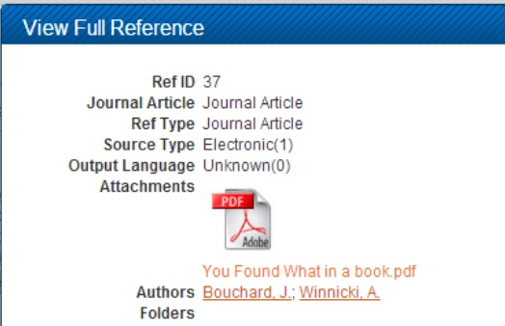

Despite these slight indicators, there are no other conceptual models, constraints or mappings utilized by the interface to indicate to users that items can be downloaded by clicking. Users have to make use of trial and error in order to discover this function, indicating poor design. Overall the functionality of uploading files to a reference does not make use of many of the fundamentals of good design, thereby making processes overly invisible and incredibly difficult for users to take advantage of this property of the interface.