Jennifer Archuleta

LIBR 210-01

Professor Todd Gilman

March 12, 2014

Exercise #2

*1. How can I find out what was going on in the literary world during World War II?*

Hello and thank you for your interesting question. I am a bit unclear about the exact type of information you are looking for, could you tell me more about what you need and the purpose of the information? Are you in need of information for an assignment or a report? Should the resources be scholarly in nature, or are informal, web resources okay? Could you specify what you mean by “literary world”? For example, are you looking for information from a specific locale, i.e. American literature, British Literature, etc.? Are you interested primarily in English Literature, or instead in non-Western Literature?

As I am not completely clear about the exact type of information you are in search of, I have provided some general resources below for you to peruse. If these resources are not useful to you, or way off the mark of the type of information you are in search of, please feel free to answer some of the questions I asked above so I can refocus my efforts to find you what you need.

*Encyclopedia Britannica* [electronic resource]:

<http://www.britannica.com.libaccess.sjlibrary.org/>

Specific entry on English Literature: <http://www.britannica.com.libaccess.sjlibrary.org/EBchecked/topic/188217/English-literature>

*Scroll in table of contents to heading: “The 20th century”, then to subheading: “The literature of World War II (1939-45)”.

Here are some suggestions of Subject Headings that you can use via the Advanced Search feature from the SJSU Encore Catalog (select “Subject” from drop down menu”): <http://discover.sjlibrary.org/iii/encore_sjsu/home?lang=eng&advancedSearch=true>

World War, 1939-1945 -- Literature and the war.

World War, 1939-1945 -- Literature and the war -- Bibliography.

World War, 1939-1945 -- Bibliography.

War and literature -- United States -- History -- 20th century.

*Databases:*

Links to databases you have access to as a SJSU student (must enter your SJSU student ID and library PIN to access), that may be relevant finding information about literature and the literary world during WWII-

Literature Online: Reference Edition:

<http://lionreference.chadwyck.com.libaccess.sjlibrary.org>

This database includes the *Annual Bibliographic of English Language and Literature (ABELL)*, full-text journals, Cambridge Companions to Literature (219 volumes), in addition to reference works (biographies, bibliographies, etc.), and links to websites.

The Johns Hopkins Guide to Literary Theory & Criticism: <http://litguide.press.jhu.edu.libaccess.sjlibrary.org/>

*Books:*

These are books available either in the SJSU library collections or available through Link+ (our interlibrary loan service).

From SJSU Library collections:

*The Oxford companion to English literature,* edited by Dinah Birch- <http://discover.sjlibrary.org/iii/encore_sjsu/record/C__Rb3915715>

Available from Link+:

*Cambridge companion to the literature of World War II,* edited by Marina MacKay- [http://csul.iii.com/record=b28913544~S0*eng](http://csul.iii.com/record=b28913544~S0*eng)

*Understanding the literature of World War II: a student casebook to issues, sources, and historical documents,* by James H. Meredith- [http://csul.iii.com/record=b14982695~S0*eng](http://csul.iii.com/record=b14982695~S0*eng)

*The Novels of World War II: an annotated bibliography,* by Desmond Taylor- [http://csul.iii.com/record=b10673154~S0*eng](http://csul.iii.com/record=b10673154~S0*eng)

*American war literature, 1914 to Vietnam*, by Jeffrey Walsh- [http://csul.iii.com/record=b10307544~S0*eng](http://csul.iii.com/record=b10307544~S0*eng)

*British writing of the Second World* *War,* by Mark Rawlinson- [http://csul.iii.com/record=b15053195~S0*eng](http://csul.iii.com/record=b15053195~S0*eng)

*The Norton Anthology of America Literature*, edited by Nina Baym- [http://csul.iii.com/record=b25483418~S0*eng](http://csul.iii.com/record=b25483418~S0*eng)

*Website Links*:

Overviews from The Norton Anthology of American Literature: <http://wwnorton.com/college/english/naal8/section/volD/overview.aspx>

<http://www.wwnorton.com/college/english/naal7/contents/D/welcome.asp>

Literary Movements by Spark Notes: <http://sparkcharts.sparknotes.com/lit/literaryterms/section5.php>

20th century and the World Wars: <http://web.cocc.edu/cagatucci/classes/eng109/C20WorldWars.htm>

Process of finding answer:

This question was a difficult for me to answer because I wasn’t exactly clear about the type of information requested. As the question was quite broad, for example I wasn’t sure what “literary world” the user was exactly interested in (all English literature, American, British, elsewhere, etc.), I tried to provide several different options for finding relevant information, in addition to specific works. I browsed the SJSU library catalog for relevant books, subject headings, and resources that could be useful. I also included links to two literature databases which I felt the user could use to look for more information on their own. I also did a general web search to look for non-scholarly websites that provided a general overview of the topics mentioned by the user. In general, I tried to provide a wide net of resources for the user so that they could see what worked or didn’t work for them, and also provided the opportunity for them to contact me again if the information provided was not helpful to them.

References

Baym, N. (2007). *The Norton anthology of American literature* (7th ed.)*.* New York, NY: Norton.

Birch, D. (2009). *The Oxford companion to English literature* (7th ed.)*.* New York, NY: Oxford University Press.

Meredith, J. H. (1999). *Understanding the literature of World War II: a student casebook to issues, sources, and historical documents*. Westport, CT: Greenwood Press.

Rawlinson, M. (2000). *British writing of the Second World War.* New York, NY: Clarendon Press.

Taylor, D. (1993). *The novels of World War II: an annotated bibliography*. New York, NY: Garland.

Walsh, J. (1982). *American war literature, 1914 to Vietnam*. New York, NY: St. Martin’s Press.

2. *How can I find circulation statistics (i.e., how many subscribers there are) for the scholarly journal ELH?*

Hello and thank you for contacting the SJSU King Library Reference Department. In order to find the circulation statistics of a periodical you can use the electronic database, *MLA Directory of Periodicals*, which you have access to as a SJSU student.

You can access the database by simply typing the name of it in into the Encore catalog: <http://discover.sjlibrary.org/iii/encore_sjsu/?lang=eng>, which will bring you to its record here: <http://discover.sjlibrary.org/iii/encore_sjsu/record/C__Rb4164383>.

Once you are logged in with your name, SJSU ID, and library PIN, you can go ahead and search for “ELH” in the box. One result should come up, and here is a permalink to the record from the *MLA Directory of Periodicals*: [http://libaccess.sjlibrary.org/login?url= http://search.ebscohost.com/login.aspx?direct=true&db=kah&AN=00818&site=ehost-live](http://libaccess.sjlibrary.org/login?url=%20http://search.ebscohost.com/login.aspx?direct=true&db=kah&AN=00818&site=ehost-live)

Listed in this record is all the information about this journal. The data you need will be listed under “Publication Details”, which lists “Circulation” at 1,940 (fourth piece of data under this section) for this journal.

I hope this information was able to fully address your question. If you are in need of further assistance, or if this information was not helpful to your query, please do not hesitate to contact me again. Thank you again for contacting the SJSU King Library Reference Department, and I hope you have a great day.

Process of finding answer:

When I saw this question I immediately turned to Ulrich’s Periodical Directory because I have used it in the past to find information about specific journals. Unfortunately, when I located the information about *ELH*, I found that there were no circulation statistics for the journal listed. I remembered from our recent textbook reading about another periodical directory, so I went back to the databases chapter to find the title of the database. I learned it was called the MLA Directory of Periodicals, and then searched for the resource on the SJSU Library catalog where I was able to access it. From here I was able to find the circulation statistics for the journal, listed within the “publication details” of the entry about *ELH*. I actually found this periodical directory to be quite useful because of its “GetText” feature, which shows you if it is accessible through SJSU, and I thought the layout was much less chaotic and clear than Ulrich’s Periodical Directory.

3. *I need to write a paper on colonialism in Shakespeare's play The Tempest. Can you help me find some appropriate scholarly books and peer-reviewed journal articles on this topic?*

Hello and thank you for your question, I am more than happy to provide you with some appropriate books and scholarly, peer-reviewed articles regarding this topic.

*Books:*

From the SJSU Catalog:

*Shakespeare, race, and colonialism* by Ania Loomba: <http://discover.sjlibrary.org/iii/encore_sjsu/record/C__Rb1967531>

*Critical essays on Shakespeare’s The Tempest*, edited by Virginia Mason Vaughan and Alden T. Vaughan: <http://discover.sjlibrary.org/iii/encore_sjsu/record/C__Rb1801984>

*Shakespeare and race: a postcolonial praxis in the early modern period*, by Imtiaz Habib: <http://discover.sjlibrary.org/iii/encore_sjsu/record/C__Rb1854054>

*Post-colonial theory and English literature* [eBook], edited by Peter Childs: <http://discover.sjlibrary.org/iii/encore_sjsu/record/C__Rb1911864>

*Shakespeare: an Oxford guide,* edited by Stanley Wells and Lena Cowen Orlin: <http://discover.sjlibrary.org/iii/encore_sjsu/record/C__Rb2510267>

Available through Link+:

*The Tempest: a case study in critical controversy* by William Shakespeare, edited by Gerald Graff and James Phelan: [http://csul.iii.com/record=b36137186~S0*eng](http://csul.iii.com/record=b36137186~S0*eng)

(Several chapters dealing with colonialism)

Subject Heading suggestions for catalog searches:

Shakespeare, William, 1564-1616. Tempest

Shakespeare, William, 1564-1616 – Views on imperialism.

Shakespeare, William, 1564-1616 – Views on race.

*Databases:*

The Shakespeare Collection: [http://shakespeare.galegroup.com.libaccess.sjlibrary.org/ shax/start.do?prodId=SHAX&userGroupName=csusj](http://shakespeare.galegroup.com.libaccess.sjlibrary.org/%20shax/start.do?prodId=SHAX&userGroupName=csusj)

JSTOR: <http://www.jstor.org.libaccess.sjlibrary.org/>

Literature Online Reference Edition: <http://lionreference.chadwyck.com.libaccess.sjlibrary.org/>

Project Muse: <http://muse.jhu.edu.libaccess.sjlibrary.org/>

English and Comparative Literature Quick Search: http://libaccess.sjlibrary.org /login?url=http://search.ebscohost.com/login.aspx?direct=true&db=aph&AN=4722698&site=ehost-live

*Relevant Journals* (some online access through SJSU databases):

Shakespeare (UK) (2005- )

Shakespeare Newsletter (1951- )

Shakespeare Quarterly (1924- )

Shakespeare Studies (1960- )

*Articles:*

Fuchs, B. (1997). Conquering islands: Contextualizing the tempest. *Shakespeare Quarterly, 48*(1), 45-62. Retrieved from <http://www.jstor.org.libaccess.sjlibrary.org/stable/2871400>

Schneider, B. R., Jr. (1995). “Are we being historical yet?”: Colonialist interpretations of Shakespeare’s tempest. *Shakespeare Studies, 23*, 210. Retrieved from <http://libaccess.sjlibrary.org/login?url=http://search.ebscohost.com/login.aspx?direct=true&db=aph&AN=9512020954&site=ehost-live>

Skura, M. A. (1989). Discourse and the individual: The case of colonialism in “the tempest”. *Shakespeare Quarterly*, *40*(1), 42-69. Retrieved from <http://www.jstor.org.libaccess.sjlibrary.org/stable/2870753>

Willis, D. (1989). Shakespeare’s tempest and the discourse of colonialism. *Studies in English Literature, 1500-1900, 29*(2), 277-289. Retrieved from <http://www.jstor.org.libaccess.sjlibrary.org/stable/450475>

Zolfagharkhani, M., & Heshmatifar, Z. (2012). Pedagogical and colonial power discourses in William Shakespeare’s the Tempest. *Cross-Cultural Communication, 8*(2), 7-14. Retrieved from <http://search.proquest.com.libaccess.sjlibrary.org/docview/1019053147/abstract?accountid=10361>

Process of finding answer:

This user was very specific about the topic and the type of materials they needed. Because the user specified the need for books and scholarly articles, I limited my searched of materials to the SJSU catalog and to databases available. While I provided the results of the books and articles that I found that would be of use to the user, I also tried to provide information such as relevant subject headings, databases, and scholarly journals so they could continue their search on their own. In order to find the best databases to search for articles I browsed the databases listed by subject in English and Comparative Literature (<http://library.calstate.edu/sanjose/databases/subject/english-and-comparative-literature>), in addition to the databases listed in our course textbook.

References

Childs, P. (1999). *Post-colonial theory and English literature.* Edinburgh, Scotland: Edinburgh University Press.

Habib, I. H. (2000). *Shakespeare and race: postcolonial praxis in the early modern period*. Lanham, MD: University Press of America.

Loomba, A. (2002). *Shakespeare, race, and colonialism.* New York, NY: Oxford University Press.

Shakespeare, W. (2009). *The tempest: a case study in critical controversy.* G. Graff & J. Phelan (Eds.) Boston, MA: Bedford/St. Martins.

Vaughan, V. M., & Vaughan, A. T. (1998). *Critical essays on Shakespeare’s the tempest*. New York, NY: Prentice Hall.

Wells, S., & Orlin, L. C. (2003). *Shakespeare: an Oxford Guide.* New York, NY: Oxford University Press.

4. *How do clouds form? Which clouds produce rain?*

Hello and thank you for your questions! I believe that this seven part overview about clouds created by JetStream: Online School for Weather by the National Weather Service will be able to answer your questions: [http://www.srh.noaa.gov/jetstream// clouds/clouds_intro.htm](http://www.srh.noaa.gov/jetstream//%20clouds/clouds_intro.htm)

The included sections are: 1. Introduction, 2. How Clouds Form, 3. The Core Four, 4. The Basic Ten, 5. Sky Watcher Chart, 6. Color of Clouds, and 7. Review Questions. Your question, “How do clouds form?” will be best answered by the information in section 2. Your second question, “Which clouds produce rain?” will be best answered by the information in sections 3 and 4.

I hope this resource was able to fully answer your questions about clouds. If the information was not relevant or you needed further information, please do not hesitate to contact me again so I can refocus my efforts. Thank you for contacting the SJSU King Library Reference Department, and have a great day.

Process of finding answer:

I recently had similar question myself about different kinds of clouds and their characteristics, and remembered finding this particular resource from NOAA and the National Weather Service. Because of this, I knew that the site was reliable in authority and that it would be able to fully answer this user’s questions, so I looked for the site again through a web search. I thought it would be helpful to point out the contents of the resource to the user and direct them to the sections most useful in answering their particular questions.

5. *I need book reviews of W. E. B. Du Bois's book The Souls of Black Folk. It was first published way back in 1903. Can you help me find reviews from that year or shortly thereafter?*

Hello and thank you for your question. As *The Souls of Black Folk* by W.E.B. DuBois is an older work, and you are searching for reviews written near the time of publication.

The three best databases available for older book reviews available to you as a SJSU student are:

Book Review Digest Retrospective, 1903-1982 (<http://web.a.ebscohost.com.libaccess.sjlibrary.org/ehost/search/advanced?sid=203053b2-371a-4c92-931f-6a8a08912eda%40sessionmgr4004&vid=1&hid=4107>)

Readers Guide Retrospective, 1890-1982

(<http://web.a.ebscohost.com.libaccess.sjlibrary.org/ehost/search/advanced?sid=b6785b7c-4a2a-42f9-beb5-a1090995a345%40sessionmgr4004&vid=1&hid=4107>)

ProQuest Historical Newspapers

*The New York Times*, 1851-1993*:* (<http://search.proquest.com.libaccess.sjlibrary.org/hnpnewyorktimesindex/index?accountid=10361>)

*San Francisco Chronicle*, 1865-1922*:* (<http://search.proquest.com.libaccess.sjlibrary.org/hnpsfchronicle?accountid=10361>)

Using Reader’s Guide Retrospective, which contains historical information/documents from 1890 through 1982, I was able to locate this review from July 1903 about the book from the *Annals of the American Academy of Political & Social Science* (permalink to record:<http://libaccess.sjlibrary.org/login?url=http://search.ebscohost.com/login.aspx?direct=true&db=rgr&AN=523728456&site=ehost-live>). In the record you can find links to the full-text (if available) using the “GetText” feature, which will look for this item in the other databases subscribed to by SJSU:

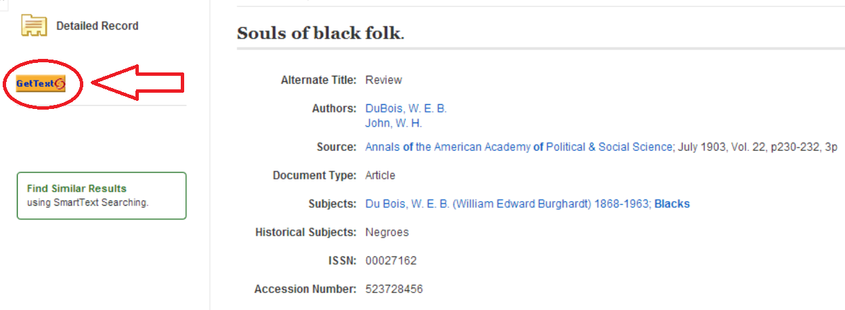

When clicked, you will be brought to the SJSU King Library GetText page, which will tell you if the full-text review is available from other databases:

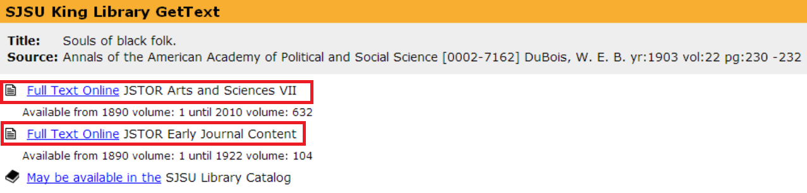

For this particular review there are two sources for the full-text: JSTOR Arts and Sciences VII and JSTOR Early Journal Content (highlighted in red boxes above). Clicking on either of these full-text hyperlinks will bring you to a digital copy of the review, which can be saved as a PDF on your computer.

As I was able to locate this review using JSTOR, I thought it might be fruitful to do a search on this database as well. Using the Advanced Search feature, I searched for the title of the book, and limited “item type” to reviews. As we are looking for older reviews, I used the “sort by”, drop down menu to sort results from “oldest to newest”, and then looked for items from 1903 (book publication date) and after. Using this search strategy, I was able to locate another review of the book from July 1903, in the *American Journal of Sociology*, by Theophilus Bolden Steward (permalink to record: <http://www.jstor.org.libaccess.sjlibrary.org/stable/2762314>), of which there is also full-text access on the database itself.

Using ProQuest Historical Newspapers to search The New York Times (1851-2010), I also able to locate another review published in April 1903 in the newspaper. Using the standard search bar, I searched for the title of the book in quotation marks- “The Souls of Black Folk”. As there are only 71 results for this search, there is not the need to further limit results by type through the advanced search feature. A longer results list might warrant limiting type to “Review”, etc. I then sorted results to “Publication date (oldest first)”, so that we could look for reviews near 1903 more easily. Using this search strategy, the second result on the list is an article and review about *The Souls of Black Folk (*[http://search.proquest.com.libaccess.sjlibrary.org/ docview/96325027?accountid=10361](http://search.proquest.com.libaccess.sjlibrary.org/%20docview/96325027?accountid=10361)).

I hope these resources will help you find the reviews of the book *The Souls of Black Folk* that you need. If these steps do not provide you with what you are looking for, please feel free to contact me again, and I will refocus my efforts. Thank you for contacting the SJSU King Library Reference Department, have a great day.

Process of finding answer:

The user was quite specific in what they were looking for, but it was slightly difficult for me to find reviews for them. I used the Book Review databases suggested in our course textbook, but as the book was originally published in 1903, I could not find any reviews in the Book Review Digest Retrospective, 1903-1982, because reviews didn’t start until 1905 (even though it states an earlier date). I was able to find a few book reviews and shared my search strategies with the user. Though I didn’t find book reviews in the Book Review Digest Retrospective, I did list it as a possible resource for the user in the future when looking for older book reviews. Though I originally did not search in JSTOR for book reviews, because I was able to find the full text for another review on there, I thought it would be good to conduct a search for reviews on the database as well. Using this strategy proved useful because I was able to find other historical book review for the user.

References

Kelsey, C. (1903). [Review of the book *The souls of Black folk*, by W. E. B. DuBois]. *Annals of the American Academy of Political and Social Science, 22*, 230-232. Retrieved from <http://www.aapss.org/>

Steward, T. B. (1903). [Review of the book *The souls of Black folk*, by W. E. B. DuBois]. *American Journal of Sociology, 9*(1), 136-137. Retrieved from <http://www.press.uchicago.edu/ucp/journals/journal/ajs.html>

The Negro question: Essays and sketches touching upon it by a colored writer. (1903). [Review of the book *The souls of Black folk,* by W. E. B. DuBois]. *New York Times,* 283. Retrieved from http://search.proquest.com.libaccess.sjlibrary.org /docview/96325027?accountid=10361

6. *I have to write a paper for my Linguistics class on an obscure language that not many people speak. I want to look into Vanuatu languages, perhaps the language known as Mwotlap. Can you help me find some information on these languages?*

Hello and thank you for your interesting question. I understand you are looking for information about the Vanuatu language, Mwotlap. In order to better help you, could you tell me a little bit more about the type of information you are interested in about the language group, and the Mwotlap language so that I can refocus my search on what aspects you are specifically interested in. For example, are you in need of scholarly, peer-reviewed articles, books, or more informal articles from periodicals? Are you interested in a particular aspect of the language, such as grammar or semantics?

To get you started here is a link to the Linguistics and Language LibGuide prepared by a SJSU Librarian: <http://libguides.sjsu.edu/LLD>. In this subject guide you will find links to online tutorials on how to conduct library research, links to the major databases most relevant to this subject area, and links to outside websites in this field.

*Books*

Available in the SJSU Library collection:

*International Encyclopedia of Linguistics*, edited by William J. Frawley. Volumes 1-4: <http://discover.sjlibrary.org/iii/encore_sjsu/record/C__Rb2078141>

*The Cambridge Encyclopedia of Language*, by David Crystal: <http://discover.sjlibrary.org/iii/encore_sjsu/record/C__Rb1773855>

*Encyclopedia of Language and Linguistics,* edited by Keith Brown. Volumes 1-14: <http://discover.sjlibrary.org/iii/encore_sjsu/record/C__Rb2778477>

*Language Planning and Policy in the Pacific. Vol. 1, Fiji, the Philippines and Vanuatu,* edited by Richard B. Baldauf Jr. and Robert B. Kaplan: <http://discover.sjlibrary.org/iii/encore_sjsu/record/C__Rb3226878>

*Austronesian and theoretical linguistics* [eBook], edited by Raphael Mercado, Eric Potsdam, and Lisa deMena Travis: <http://discover.sjlibrary.org/iii/encore_sjsu/record/C__Rb4604045>

*Clause structure and adjuncts in Austronesian languages* [eBook], edited by Hans-Martin Gartner, Paul Law, and Joachim Sabel: [http://discover.sjlibrary.org/iii/encore_sjsu/ record/C__Rb4609864](http://discover.sjlibrary.org/iii/encore_sjsu/%20record/C__Rb4609864)

*Language Diversity Endangered,* edited by Matthias Brenzinger. (Chapter 17- The Languages of the Pacific Region: the Austronesian Languages of Oceania by Darrell Tryon- may especially be of use): <http://discover.sjlibrary.org/iii/encore_sjsu/record/C__Rb3370529>

Available through Link+:

*The Oceanic Languages* by John Lynch, Malcolm Ross and Terry Crowley: [http://csul.iii.com/record=b21275803~S0*eng](http://csul.iii.com/record=b21275803~S0*eng)

*Databases:*

Linguistics & Language Behavior Abstracts (<http://search.proquest.com.libaccess.sjlibrary.org/llba/index?accountid=10361>)

MLA International Bibliography (<http://web.b.ebscohost.com.libaccess.sjlibrary.org/ehost/search/advanced?sid=5993b2bd-44fa-47ab-a87e-a78c000657e3%40sessionmgr114&vid=1&hid=112>)

Communication & Mass Media Complete (<http://web.b.ebscohost.com.libaccess.sjlibrary.org/ehost/search/advanced?sid=ac675776-4162-48b4-a18b-1606881e36d6%40sessionmgr115&vid=1&hid=112>)

ComDisDome (<http://search.proquest.com.libaccess.sjlibrary.org/comdisdome?accountid=10361>)

Some search terms that may be useful for you are (database and catalog searches):

Vanuatu

Mwotlap

Motlav

Oceanic languages

Austronesian languages

*Subject Headings:*

Oceanic languages.

Vanuatu.

As Vanuatu is classified as an Austronesian language, I browsed our Electronic Journals Index under the subject, Languages & Literatures, which led to me 4 journals specifically dealing with these languages. The journal probably most useful to you will be, Oceanic Linguistics (<http://qd3kb7rg4f.search.serialssolutions.com/?V=1.0&N=100&L=QD3KB7RG4F&S=AC_T_B&C=Oceanic+linguistics>).

*Websites:*

Ethnologue: Languages of the World, entry on Mwotlap: <http://www.ethnologue.com/language/mlv>

OLAC resources in/about the Motlav (Mwotlap) language: <http://www.language-archives.org/language/mlv>

Linguistic Resources compiled by SIL International: <http://www-01.sil.org/linguistics/topical.html>

Alex Francois, linguist in Melanesia: <http://alex.francois.free.fr/AF-motalava-e.htm>

Process of finding answer:

Though the user was quite clear about the information they needed and what it was needed for, there was still not entirely enough information for me to narrow down on specific resources for them. For example, what aspects of the language were they interested in? Because of this lack of specificity, I tried to point the user to variety of resources including books in the library catalog, relevant databases, the Linguistics LibGuide, and websites. I also invited the user to return to me with answers to the question I posed if the resources and information provided by me was off track, so I could focus on exactly what they were looking for. The entry from the Ethnologue, helped me identify other names for the Mwotlap language, in addition to it’s broader language families, which was helpful in searching for resources as finding specific information on Mwotlap itself was difficult. Using this information I tried to provide more general sources about Austronesian and Oceanic languages which might include information about Mwotlap.

References

Baldauf, Richard, B., Jr., & Kaplan, R. B. (2006). *Language planning and policy in the Pacific. Vol. 1, Fiji, the Philippines and Vanuatu*. Buffalo, NY: Multilingual Matters.

Brenzinger, M. (2007). *Language diversity endangered*. Berlin, NY: Mouton de Gruyter.

Brown, K. (2006). *Encyclopedia of language & linguistics* (2nd ed.) (Vols. 1-14). Boston, MA: Elsevier.

Crystal, D. (1997). *The Cambridge encyclopedia of language* (2nd ed.)*.* New York, NY: Cambridge University Press.

Frawley, W. J. (2003). *International encyclopedia of linguistics* (2nd ed.) (Vols. 1-4). New York, NY: Oxford University Press.

Gartner, H., Law, P., & Sabel, J. (2006). *Clause structure and adjuncts in Austronesian languages*. Berlin, NY: Mouton de Gruyter.

Lynch, J., Ross, M., & Crowley, T. (2002). *The Oceanic languages*. Surrey, England: Curzon.

Mercado, R., Potsdam, E., & Travis, L. D. (2010). *Austronesian and theoretical linguistics*. Amsterdam, PA: John Benjamins Pub. Company.

7. *I am looking for the full text of a specific book review of a poet by the name of Christian Wiman. It is a review that appeared in The Philadelphia Inquirer: Review of “Ambition and Survival: Becoming a Poet,” in the Philadelphia Inquirer, January 20, 2008, by Frank Wilson. Is the full text available online somewhere?*

Hello and thank you for your question. This newspaper, *The Philadelphia Inquirer*, is accessible from the Database ProQuest Newsstand:

<http://search.proquest.com.libaccess.sjlibrary.org/newsstand/index?accountid=10361>

These are the steps we can take to determine if a particular newspaper is available through this database.

This is the front page of the database, after you have logged into it using your SJSU student ID and library PIN. From here you want to click the “Publications” link, as highlighted in the screenshot below:

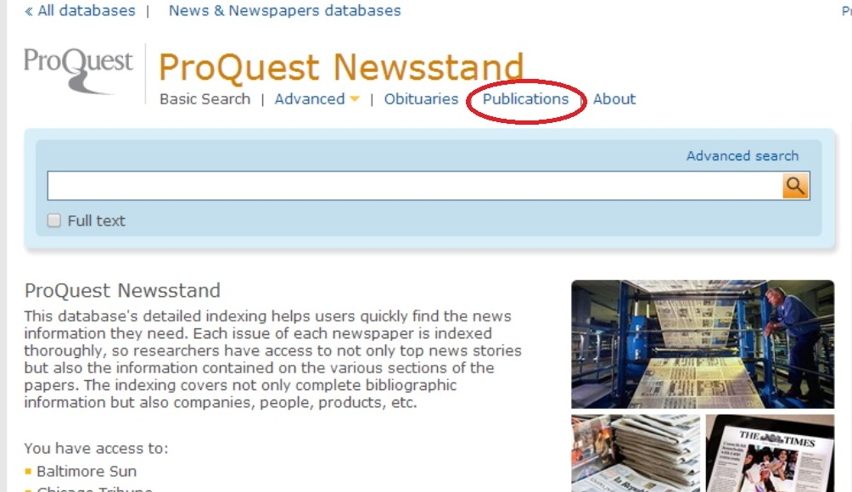

From here we select the letter “P”, which limits results (circled in red). On the right hand side there is a link to narrow publications, select “Newspapers” (red arrow):

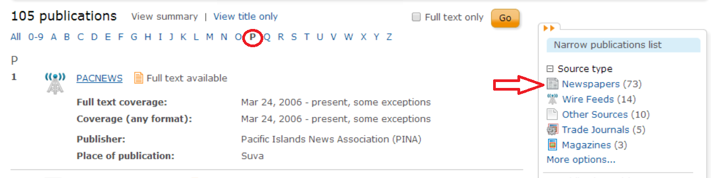

Then we scroll through the results. As can be seen, result number 30 is for the *Philadelphia Inquirer.*

This shows us the information about the newspaper available on the database. We can see that there is full text available, and that this begins starting 1983 through present date, which is within the timeframe of the review we are searching for:

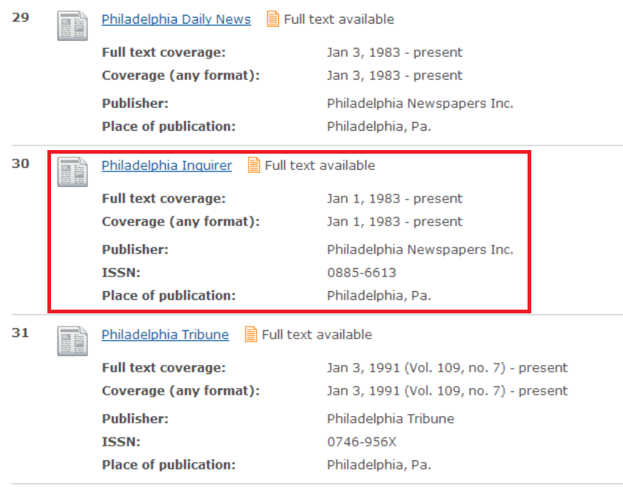

When we click on the name of the publication from the results list we are brought to the specific page for this newspaper. From this page we have the option to search within it, or browse by year, date, month, and specific issue. For this search, since we know so much of the information about the review needed, we can simply do a search for the name of the author and a title of the book (search feature highlighted with red arrow below):

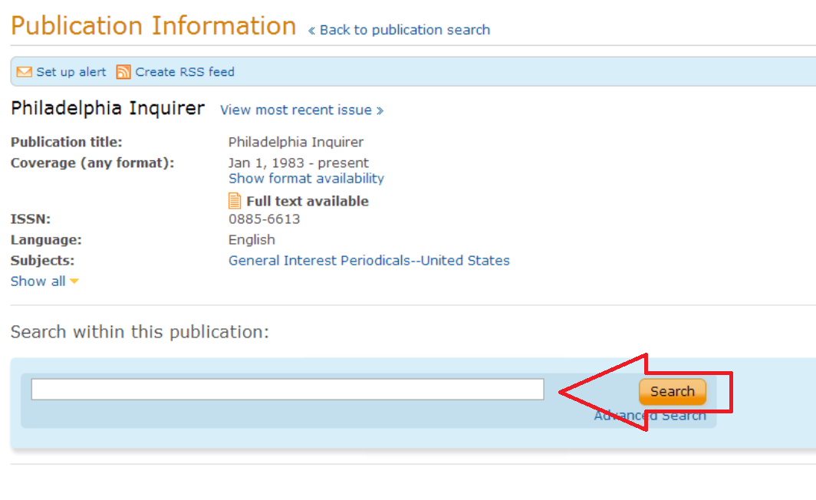

Using this search strategy, the full text review can be located from: <http://search.proquest.com.libaccess.sjlibrary.org/docview/287626110?accountid=10361>

I hope this information is helpful for you in not only finding the full text review that you were looking for, but also with a generalized search strategy on how to locate other information in newspapers using the ProQuest Newspapers database. If this information was not helpful to you, or if you have any further questions, please do not hesitate to contact me again. Thank you for contacting the SJSU King Library Reference Department, and have a great day.

Process of finding the answer:

I knew about the ProQuest Newspaper database, so this was the first place I checked to see if the *Philadelphia Inquirer* was available in full text from it. Using the steps that I took screenshots of and shared with the user, I was able to find out that the *Inquirer* was available and within the timeframe we needed. After this searching within the newspaper itself, I was able to easily locate the full text review needed by the user. Instead of just providing them with a link to the full text source itself, I provided them with steps I took to determine if the newspaper was available from the database and search for it, so that the user would know how to do this in the future for themselves (if they needed to find other articles or reviews from a specific source).

Reference

Wilson, F. (2008). A poet reconciling verse and living [Review of the book *Ambition and Survival: Becoming a Poet*, by C. Wiman]. *Philadelphia Inquirer*, C4. Retrieved from http://search.proquest.com.libaccess.sjlibrary.org/docview/287626110?accountid=10361

8. *I need some information about the actor Patrick Stewart. I think he was born around 1940.*

Hello and thank you for your question. What type of information are you interested in about the actor, Patrick Stewart? A good resource that is freely available is the Internet Movie Database, also known as IMDb. I was able to locate this page about the British actor, Patrick Stewart who was born on July, 13, 1940: <http://www.imdb.com/name/nm0001772/?ref_=nv_sr_1>

Included on this page is a biography, filmography, awards, photos, related news, and other information related to Patrick Stewart.

I hope this resource and the link provided are helpful to you. If you required other information, or if this resource did not answer your question, please contact me again and I will refocus my efforts. Thank you again for contacting the SJSU King Library Reference Department, have a great day.

Process of finding the answer:

I was aware of the Internet Movie Database from having used it before to answer questions that I had about movies and television shows. After reading in our textbook that it is a good resource for answering these types of questions, I used it to find the specific page about Patrick Stewart. Because the user wasn’t exactly clear about the type of information provided, I did offer them to return to me if the link provided to IMDb wasn’t what they were looking for.

9. *Can my library get a site license to the electronic version of the MLA Handbook for Writers of Research Papers? If so how much does it cost?*

Hello and thank you for your interesting question. According to the FAQ (

<http://www.mla.org/style/handbook_faq/handbookfaq_license>) on the Modern Language Association website, “No site licenses are available at this time.” MLA also has provided a “Note to Librarians” for an explanation on why they do not offer a site license, in addition to information about their business model which can be viewed here: <http://www.mlahandbook.org/fragment/note_to_librarians>

I hope this information was able to fully answer your question. If you need further information about this query, or if you have any other questions, please feel free to contact me again. Thank you for contacting the SJSU King Library Reference Department, and have a great day.

Process of finding the answer:

For this question I wasn’t sure exactly was the MLA Handbook was, or what a site license was, so I did a quick web search using Google to try to find out generally what these were. Using the terms “site license” and “MLA handbook” brought me directly to the FAQ page of the Modern Language Association website with an answer to the question. Instead of just providing the answer of “no” to the user, I instead provided links to where I found the answer, so they could confirm it themselves, in addition to relevant information provided by the MLA on their website.

10. *Which Presidents of the United States have also served as Justices on the US Supreme Court?*

Hello and thank you for contacting the SJSU King Library Reference Department with your question. I was able to find the answer to your question by using a database available to you as a SJSU student, CQ Press U.S. Political Stats (beta): <http://library.cqpress.com.libaccess.sjlibrary.org/uspoliticalstats/>

Using this database we can view political statics including both a list of past United States presidents and Supreme Court Justices. Simple mouse over the “People” on the browse by toolbar, to and click on Presidency and/or Supreme Court (red arrows below):

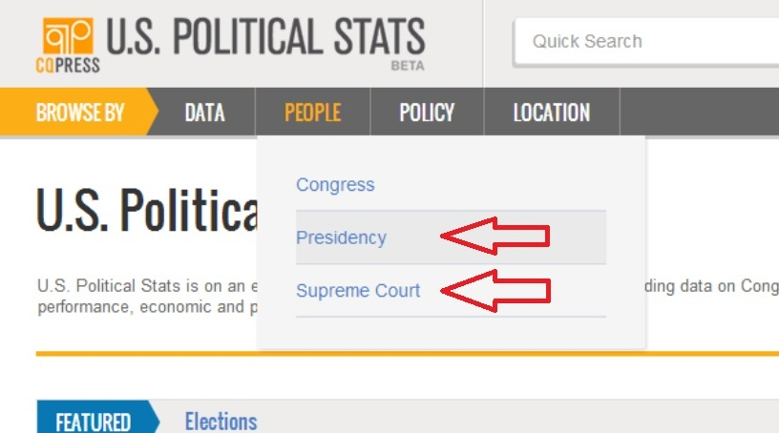

Using the lists of all 43 people who have held the U.S. presidency and the 112 people who are on, or have been on the U.S. Supreme Court, I was able to determine that only William Howard Taft, U.S. President in 1903-1913, also served as Chief Justice from 1921-1930.

I hope this information was able to full answer your question. If you are in need of further assistance with this query, or have any other questions, please do not hesitate to contact me again. Thank you for your question, and have a great day.

Process of finding answer:

For this question, I searched through the available databases to SJSU students at <http://library.calstate.edu/sanjose/databases>, and found that CQ Press U.S. Political Stats had the type of information I was looking for. Using this database I sorted the list of Presidents and Supreme Court Justices alphabetically, and then manually compared and contrasted the two to look for any overlapping names. After seeing that William Howard Taft was the only person to appear on both lists I did a quick web search to make sure this information was correct.